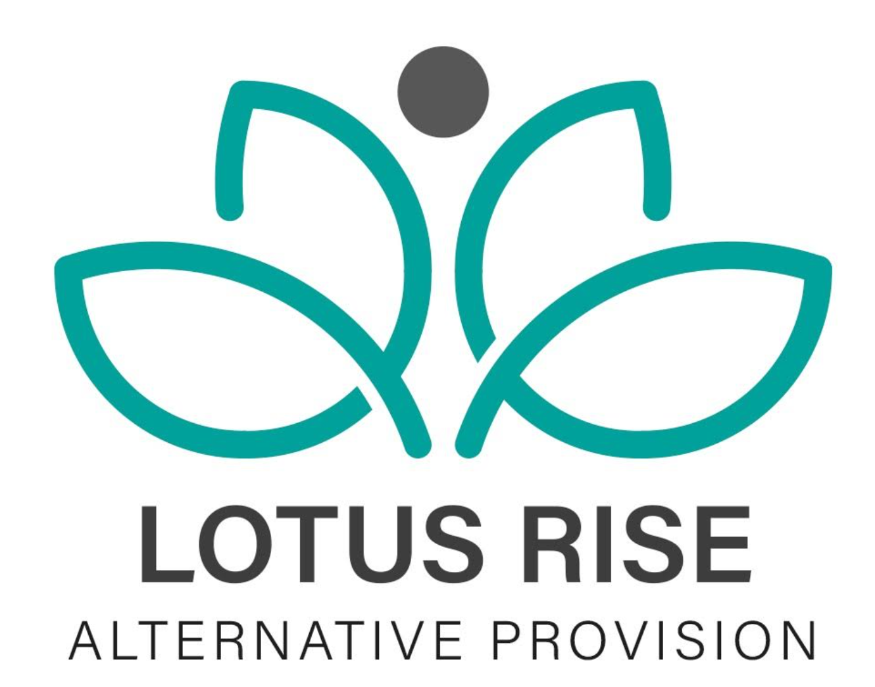
COMPLETED DATE:7/5/24
DATE OF NEXT REVIEW:7/5/26

Admissions Policy
Introduction
This document sets out the admission arrangements for Lotus Rise Independent School and Alternative Provision Lotus Rise operates a fair, objective, and transparent admissions process.
Admission Arrangements Pupils of compulsory school age can only be admitted to Lotus Rise by being referred by local authorities, schools, and academies.
All admissions are made via a referral process. Each pupil will be assessed individually by Lotus Rise staff to ensure that a place at Lotus Rise is both appropriate and in their best interests.
The table below sets out most circumstances under which a referral may be made (the list is indicative only):
Pupil is permanently excluded
- Full-time
- Long term or short term
- Education must start by the sixth day of permanent exclusion but can start earlier.
Pupil has a fixed period exclusion
- Full-time Short term – up to 45 school days in an academic year
- Education must start by the sixth day of a fixed period exclusion but can start earlier.
Pupil cannot attend education due to illness (section 19 Education Act 1996)
- Part-time if medication reasons make this appropriate
- Long term or short term
Pupil has behavioural issues (including pupils at risk of exclusion and those directed offsite for education to improve their behaviour)
- Full-time or part-time depending on whether the pupil is receiving education elsewhere to make up to full-time.
- Short term or medium term.
Young mother
- Short term – up to 18 weeks
- Full-time or part-time depending on the young mother’s circumstances
Children whose Elective Home Education has been failed
- Full-time
- Short term or medium term
Children who are identified as Children Missing Education
- Full-time
- Short term or medium term
Children considered under the Fair Access Protocol
- Full-time
- Short term or medium term

Lotus Rise will be working with several partner providers within Work Experience, and can meet the needs of boys and girls aged 11 to 16 who are either permanently excluded or at risk thereof, suffering extended periods of sickness or, for medical reasons, are unable to attend school, and may require Outreach 1:1 or/and Work Experience.
Other ages will be considered at the discretion of the Directors and Senior leadership team. Lotus Rise aims to provide flexibility in places and therefore the numbers admitted in specific locations and key stages are subject to change.
Pupils may be accepted into relevant year groups depending on demand. Places will be reviewed by Lotus Rise Directors at agreed intervals, in line with good practice and statutory guidance.
Oversubscription Criteria Places which are requested for pupils will be prioritised using the following criteria:
• Children who have been permanently excluded and
• those who have a medical reason which means that they cannot attend a mainstream school
• Children who are at risk of exclusion

Appeals
The statutory admission appeals process does not apply to Lotus Rise Correspondence 4 Any correspondence should always be posted in sealed envelopes marked ‘Confidential’, with the recipient’s name written clearly on it. If there is any data protection breach, disciplinary action will be applied.

Review Date | By Who?
9/6/2025 | edawber

