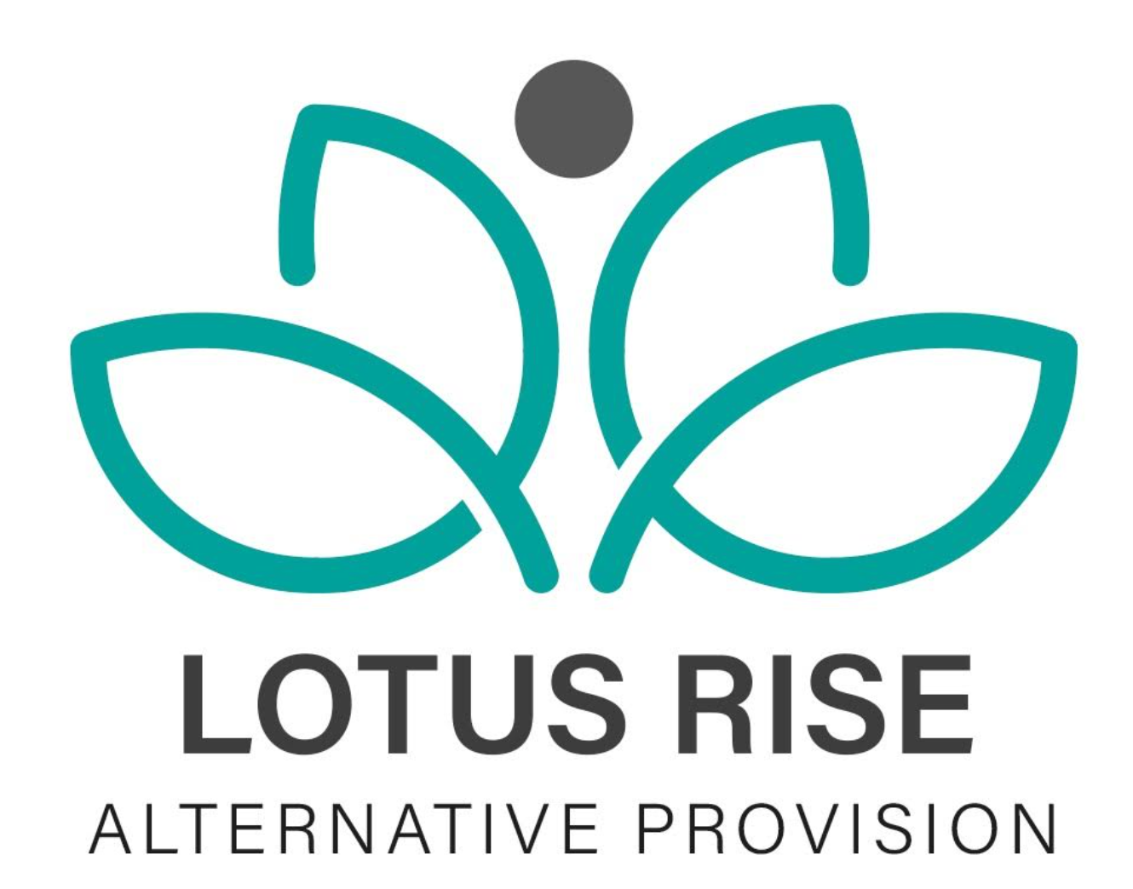
COMPLETED DATE:7/5/24
DATE OF NEXT REVIEW:7/5/26

Anti-Bullying Policy
We do not tolerate bullying of any kind at Lotus Rise, we believe that the students have the right to feel happy, safe and included to work in a secure and safe environment where learning can take place without any harassment, intimidation or fear.
This Policy has been drawn up by the whole Lotus Rise learning community and we are committed to develop an anti-bullying culture whereby no bullying, including between adults or adults and students and young people will be tolerated.
Statement of Intent The Directors and the staff at Lotus Rise acknowledge the effects bullying can have on a pupil’s self-esteem and their work. We therefore do all we can to prevent bullying by developing an ethos in which bullying is regarded as unacceptable.
As a company we believe:
• Bullying is undesirable and unacceptable.
• Bullying is a problem to which solutions can be found.
• Seeking help and openness are regarded as signs of strength and not weakness.
• All members of our community will be listened to and taken seriously.
• Everyone has the right to enjoy and achieve in an atmosphere that is free from fear.
• All of us have a responsibility to ensure that we do not abuse or bully others.
• Students and young people should talk to an adult if they are worried about bullying and have a right to expect that their concerns will be listened to and treated seriously.
• Students and young people should be involved in decision-making about matters that concern them.
• We all have a duty to work together to protect vulnerable individuals from bullying and other forms of abuse.
• We tackle bullying best by encouraging an environment where individuality is celebrated and can develop without fear.
As a school, to keep in line with the Anti-Bullying Quality Mark (ABQM), Lotus Rise ensures that each of the following topics has been reviewed and implemented:
• Whole Company / School Policy
• Active pupil involvement
• Curriculum
• E-Safety
• Leadership
• Parent involvement
• Regard for vulnerable students
• Staff involvement
• Whole company / school strategic development
Definition: Bullying behaviour may be characterised by the fact that it is:
• Deliberately hurtful.
• Often repeated over a period that intentionally hurts another individual either physically or emotionally.
• Difficult for those being bullied to stop the process or defend themselves
Bullying may occur in the form of:
• Physical violence.
• Threatening behaviour, such as extortion.
• Direct and indirect verbal abuse, such as name calling and false rumour.
• Extreme teasing and taunting.
• Sexual intimidation and discrimination.
• Inappropriate use of the Internet, Social Network sites and mobile/handheld devices.
• Damage to personal possessions and property.
• Excluding people from groups/making someone isolated. • Sexism. • Comments about sexual orientation.
• Comments related to SEND (Special Educational Needs or Disability).
• Racism.
All members of the company should be actively discouraged from participating in any form of bullying and encouraged to develop attitudes and strategies that will enable them to deal effectively should they be bullied themselves.
Aims
1. To ensure that all members of the learning community can work and relax in a happy and supportive environment without the fear of being bullied.
2. To develop a culture in which bullying is not tolerated in any form and is immediately reported by all members of the learning community to the appropriate authority.
3. To encourage staff to be vigilant and to act promptly and firmly to deal with all forms of bullying.
• We will show commitment to overcome bullying through practising zero tolerance.
• We have a safe environment where all students can learn without anxiety and measures and in place to reduce the likelihood of bullying.
Objectives
1. To raise awareness of the fact that bullying is an unacceptable feature of life at Lotus Rise and will not be tolerated.
2. To reduce the number and frequency of incidents of bullying.
3. To develop a better understanding of the problems associated with bullying through PHSE
4. To improve assertive personal skills that will encourage the individual to deal with the bully in an appropriate and effective manner.
5. To make students aware of confidential sources where they may go for help and advice.
6. To monitor and record details of those bullies whose behaviour has been successfully modified because of the policy.
Strategies for Preventing Bullying:
• Have ‘anti-bullying’ lessons and awareness activities
• Involve all members of the learning community in supporting the bullying policy through modelling and teaching of the PHSE curriculum.
• All students and parents / carers are required to sign the ‘Code of Conduct’ before joining 4 Lotus Rise. This states that: “It is expected that students will not be involved in any kind of bullying”.
• Keep detailed records of reported incidents of serious and repetitive bullying.
• Encourage victims to report situations where they need support to help stop the bullying behaviour and use the support systems available.
• Ensure that management styles encourage an appropriate ethos.
• Ensure that staff act as good role models.
• Identify and support at an early stage those individuals who may be particularly vulnerable to bullying.
• Staff to be on duty around the premises before and after lessons and lunchtimes.
• Promote and remove the stigma associated with mental health.
Strategies for Dealing with Bullying:
• Create an inclusive environment which promotes a culture of mutual respect, consideration and care for others which will be upheld by all.
• Consider all opportunities for addressing bullying in all forms through the curriculum and a range of approaches; assemblies, displays, peer support and pupil voice • Provide support for victims of bullying
• Offering a high level of adult supervision both inside and outside of the building.
• Use a variety of techniques to resolve the issues between those who bully and those who have been bullied.
• Raise mental health and wellbeing awareness.
• All incidents reported to staff and passed to Safeguarding lead
1. Keep detailed records of reported incidents of serious and repetitive bullying.
2. Add to individual pupils records details of bullying and include the action taken.
3. Develop home/school links to support those families which are affected by bullying.
4. Sanctions and support for bullies which, depending upon each case, could result in one or more of the following:
• Withdrawal of privileges.
• School detention.
• Parents to be contacted by phone &/or letter.
• Inclusion.
• Liaison with outside agencies.
• Counselling.
• Restorative Justice meetings
• Full reporting to commissioning schools and collaborative action
Pupil procedures for reporting bullying:
• Talk to an adult that you trust and take a friend with you if it helps.
• Do not listen to the bully when they say that you will be in trouble if you talk to someone. You are not doing anything wrong – they are.
• What you say will be passed to your Director and the DSL, and dealt with quickly and confidentially. You will be taken seriously.
Staff procedures for reporting bullying:
• Be vigilant and watch for early signs of distress.
• Listen carefully to reports of bullying and reassure students that telling someone is not a sign of weakness.
• Offer immediate support and help and use professional judgement to assess the nature and seriousness of the incident.
• Report all incidents
• The Director or DSL will then liaise with all concerned and obtain written statements from: the victim/the bully/any witnesses including whoever first reported the incident.
• Some forms of bullying are illegal and should be reported to the Police, these include
• Violence or assault
• Theft
• Repeated harassment or intimidation, for example, name-calling, threats and abusive phone calls, emails or text messages.
• Hate crimes.
Bullying at school – GOV.UK (www.gov.uk) https://www.gov.uk/bullying -at-school
Parent procedures for reporting bullying If your child is being bullied or is bullying in the School:
• Ensure you adhere to procedures laid down by the Company.
• Contact Lotus Rise and ask to speak to the Teacher / Director / DSL
• Talk the problem over.
• Give feedback to the Director or DSL
• Work with us to support your child to have positive role model behaviour.
• Encourage your child to speak to a friend at break time or lunch time.
• To abide by the Lotus Rise Anti-Bullying Policy.
• To report any incidents of bullying to a member of staff whether directed at themselves or somebody else.
• To take full responsibility for personal behaviour and actions and treat one another with respect and kindness.
• Be an Upstander, not a Bystander to Bullying.
Roles of the Teachers/Staff at Lotus Rise:
Support and deliver a peer support system to provide our young people with a voice and initiatives to act against bullying.
Enable young students to create emotionally healthy relationships founded on concern for others and empathy for other people’s feelings.
Believe in preventing bullying before it happens, rather than solely dealing with its consequences.
Abide by Lotus Rise’s Anti-Bullying Policy to report any incidents of bullying whether it is over-heard, witnessed or directed at them.
Role of the SLT Lead regarding Anti-Bullying.
• Support the Anti bullying policy and ethos of Lotus Rise.
• Promoting the Anti-Bullying work in Director reports.
• Promoting the Anti-Bullying work in SLT Meetings.
• Support the staff in Parent Meetings.
• Enable young students to create emotionally healthy relationships founded on concern for others and empathy for other people’s feelings.
• Believe in preventing bullying in the School before it happens, rather than solely dealing with its consequences.
• Review the Policy every year and discuss with Directors before signing off
Cyber-bullying: This usually happens through calls of text on mobile phones as well as through internet chat rooms and emails. Bullying of this sort can be a criminal offence. Making offensive calls are also seen as a criminal offence; do not be afraid to tell a member of staff or the police, they take cyber-bullying very seriously.
Types of Cyber-bullying:
• Abusive text messages – Text messages that upset, embarrass, humiliate, intimidate, or frighten that can be abusive or unacceptable.
• Frightening phone calls – Calls that include silence for confusion and worry, verbal abuse, threats of physical violence and intimidation.
• Picture messages – To upset, embarrass or humiliate. Sometimes an individual does not know a picture has been taken or they may not want it to be shared. This could also include videos taken on mobile phones and can be distributed on the internet.
• Internet bullying – This is via the internet and social networking sites. Text and pictures can be used to humiliate, frighten, intimidate and or upset others.
Strategies for dealing with Cyber-bullying:
• Change your email address.
• Change your phone number.
• Stop looking through social networking sites.
• Don’t respond to negative abuse.
• Be careful who you give your contact details to (Make a note of who you give your details to).
• Always let an adult know (Save all context to show them – Do not delete anything you feel needs to be disclosed).
• If you are keeping evidence put it in a separate folder and do not look at it, this is for staff, Police, or your internet/phone provider for evidence.
• If numbers are withheld, mobile phone companies may be able to trace the account still.
• Social networking sites have buttons that enable blocking from certain people and places.
• Most social networking sites have buttons to report abuse.
LGBTQ+ – Lesbian, Gay, Bisexual and Transgender, Queer / Questioning Bullying Lotus Rise welcomes every pupil and makes it clear that homophobic, biphobic and transphobic bullying is unacceptable. Equality Act 2010
• As a School we promote equality of opportunity and foster good relations. This means doing more than just tackling homophobic, biphobic and transphobic bullying by taking proactive steps to support LGBT students and promoting respect and understanding of LGBT people and issues across the whole School community.
• As a school we must protect any pupil taking steps to reassign their sex, whether those steps are social (for example changing their name, the pronoun they prefer and the way they dress or look) or include medical intervention (for example accessing hormone therapy or having surgery). Education and Inspections Act 2006 To ensure we promote the safety and wellbeing of all students in our care, including those who are lesbian, gay, bisexual and trans and those experiencing homophobic, biphobic or transphobic bullying.
Below are examples designed to help teachers and other Lotus Rise staff to understand different types of bullying and offensive language.
Homophobic bullying is bullying that is based on prejudice or negative attitudes, beliefs, or views about lesbian, gay or bi people. Homophobic bullying may be targeted at students who are, or who are perceived to be, lesbian, gay, or bi. It can also suggest that someone or something is less worthy because they are lesbian, gay or bi.
Homophobic bullying is also often targeted at students who have lesbian, gay or bi family members, and students who do not conform to gender stereotypes or are seen to be ‘different’ in some way. Biphobic bullying is bullying based on prejudice or negative attitudes, beliefs or views specifically about bisexual people.
Biphobic bullying may be targeted at students who are openly bisexual, those who are questioning their sexual orientation, or students who are suspected of being bisexual. Biphobic bullying may target students with negative stereotyping (for example suggesting that they are greedy) or assume that being bisexual is a phase.
Transphobic bullying is bullying based on prejudice or negative attitudes, views or beliefs about trans people. Transphobic bullying affects young people who are trans but can also affect those questioning their gender identity as well as students who are not trans but do not conform to gender stereotypes. Homophobic language. This could be the casual derogatory use of the word ‘gay’ to mean something negative or the use of explicit homophobic terms.
Sexist language. There are often similarities between homophobic, biphobic and transphobic bullying and sexist language, bullying or attitudes. Sometimes a language or bullying incident may fit into more than one category.
Bullying outside the School premises: We understand that bullying can occur outside the School gates and on the way to and from the School. The bullying may be actioned by students from our own School, students from other Schools or by people who do not attend the School.
Where a pupil/parent/carer reports bullying off the School premises, we will:
• Talk to the students about how to avoid or handle bullying outside of School.
• Talk to the Directors at the other schools of whose students are bullying.
• Talk to the police.
Feedback and concerns
We recognise that there may be times when parents/carers feel that we have not dealt well with an incident of bullying and we would ask that this be brought to the Director’s attention.
The Directors will regularly monitor and evaluate our policy to ensure it is being consistently applied and any issues identified will be incorporated in the school’s action plan.
Lotus Rise aims to comply with Section 22 of the Education (No 2) Act of 1986 by maintaining an ethos and environment which will encourage and foster acceptable standards of behaviour, good personal relationships and a respect for the individual.

Review Date | By Who?
9/6/2025 | edawber

