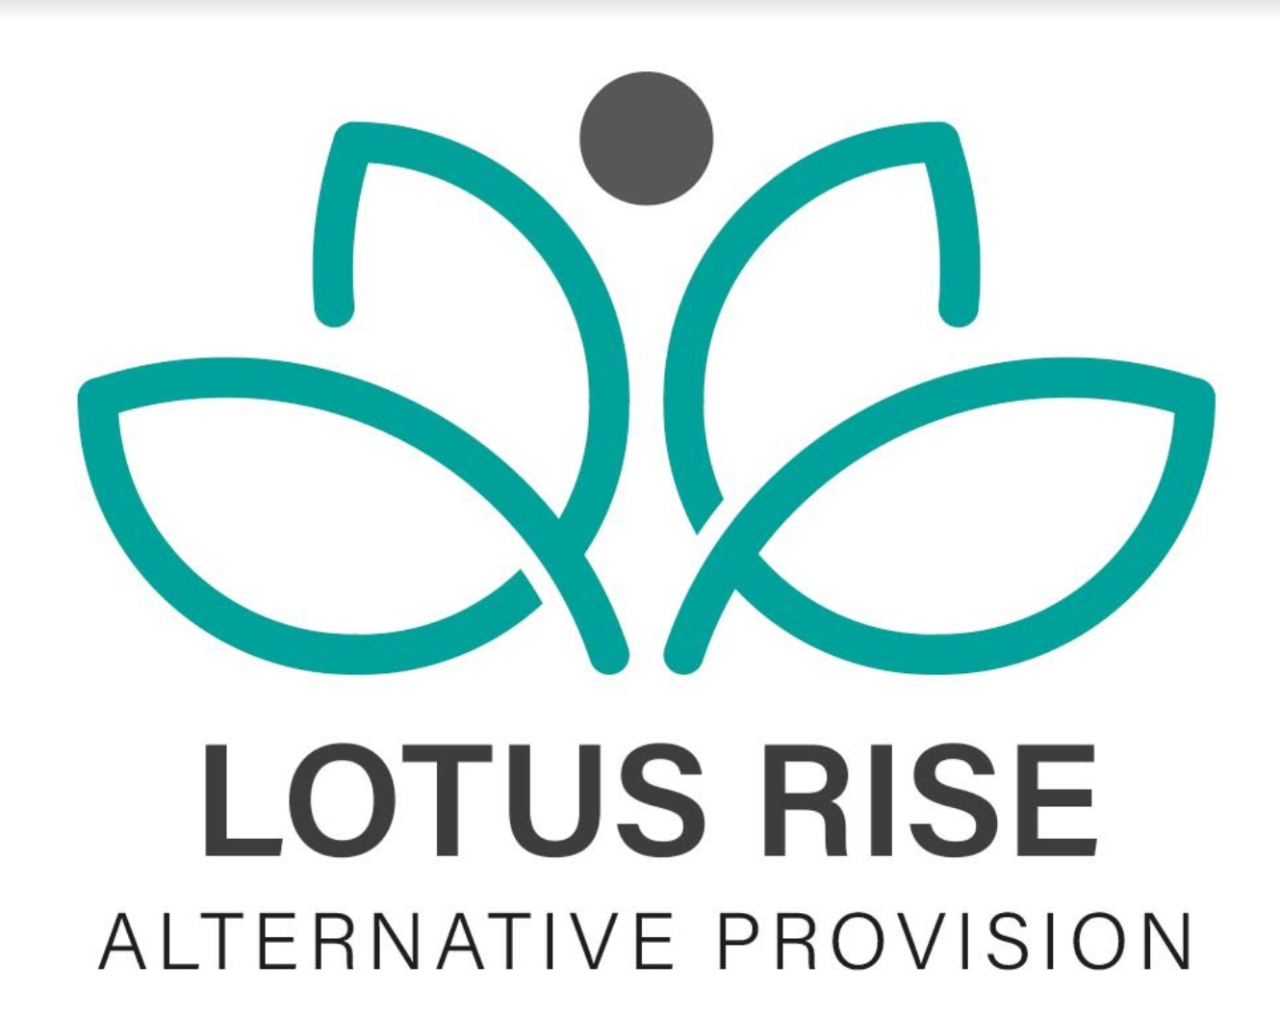
COMPLETED DATE: 9/5/24
NEXT REVIEW DATE: 4/12/26
BEHAVIOUR POLICY
Mission Statement
We are committed to high standards in all that we do. We aim to provide a stimulating and caring environment where students feel happy and secure. We encourage everyone to make the best of themselves and to achieve success.
Aims
To ensure that the provision has a wide approach to meeting the needs of students by involving all staff in actively addressing the individual needs of the students to achieve their full potential.
Our aim is to encourage all students to:
• learn to develop an understanding of the ways in which their behaviour affects their own learning and the learning of other students.
• share in the creation of a positive and orderly atmosphere where teaching and learning can take place without interruption and where students feel valued, happy and safe.
• learn to control and take responsibility for their own behaviour.
• learn to develop a responsible, supportive and caring attitude towards other people and know that their behaviour has an impact on others.
• develop a respect for property and the environment in which we all work.
Objectives
We intend to:
• provide effective teaching and learning which supports and encourages students positive behaviour and attitudes to learning.
• provide Individual Education Plans or Pastoral Support Plans where appropriate to address individual behaviour needs.
• raise and develop staff awareness of individual behaviour needs.
• provide staff with strategies to meet individual behaviour needs.
• provide students with strategies and appropriate programmes to address their individual behaviour needs.
• provide a safe environment for students, staff and visitors through the clarification of expectations of roles, rights and responsibilities.
Principles
We aim to:
• value and promote good relationships between staff, students, parents/carersand the community.
• encourage self-discipline and personal responsibility.
• assist students to develop social skills, to become responsible and well adjusted people willing and able to contribute to a caring society.
• assist with educational, vocational and personal guidance and counselling to enable students to make sensible and realistic choices.
• respect the views and beliefs of others.
• value equality of opportunity.
• encourage full attendance and punctuality.
• monitor progress and reward achievement.
• promote positive support and liaison with parents, carers and outside agencies.
Practice
Code of Conduct for students:
• Everyone should behave in a manner which shows respect.
• Respect for others.
• Respect for Lotus Rise.
• Respect for self.
Procedures
We have certain expectations of our students. We expect our students to be punctual when their mentor is collecting them. We expect them to follow their agreed timetable at all times and turn up to sessions. We expect them to wear suitable clothing as specified in the handbook. We expect them to behave in an appropriate manner and display a positive attitude towards their work.
We have clearly identified procedures in relation to whole school behaviour management in order to ensure:
• consistency and fairness.
• clarity of expectations of both staff and students.
• effective communication.

Mobile Phones, Prohibited Items and Security Screening
At Lotus Rise, the safety and wellbeing of our students and staff is our highest priority. To maintain a safe, calm, and focused environment, the following procedures are in place.

Mobile Phones and Electronic Devices
- All mobile phones and personal electronic devices must be handed in by students on arrival.
- Devices are securely stored and returned at the end of the session/day.
- Students are not permitted to keep phones on their person during the school day unless explicitly agreed as part of a risk assessment or support plan.
- Refusal to hand in a device will be managed in line with the Behaviour Policy and safeguarding procedures.

Tobacco, Vapes and Related Items
- Tobacco products, vapes, e-cigarettes, lighters, matches, or any related items are not permitted on site.
- Any such items found will be confiscated immediately.
- Confiscated items will not be returned to students and will be disposed of safely in line with organisational procedures.
- Parents/carers will be informed where appropriate.

Security Screening on Entry
- For safeguarding and risk-reduction purposes, all students are wanded with an electronic metal detector before entering the main school premises.
- This screening is carried out:
  - By trained staff
  - In a calm, respectful, and non-intrusive manner
  - As part of a consistent routine applied to all students
- The purpose of screening is to prevent prohibited or unsafe items from entering the building and to ensure the safety of everyone on site.

Safeguarding and Dignity
- All searches and screening procedures are conducted with respect, dignity, and sensitivity.
- Any concerns arising from screening will be dealt with in line with Lotus Rise safeguarding policies.
- Incidents involving confiscation or refusal to comply will be logged and reviewed to support positive behaviour and risk management.
These measures are in place to protect students, staff, and the wider school community and to create a safe environment where learning and support can take place.
Rewards
We consider the use of rewards as a key part of the behaviour management strategies used by the centre. All staff should aim to praise and encourage students at every opportunity. Rewards should be used consistently at Lotus Rise and by all staff. All students should have the opportunity to be rewarded for their contributions to the school community. Rewards for punctuality and attendance are given each term by an end of term school trip or substantial reward.
A reward can take many forms:
• spoken praise
• written praise, eg comment on work
• comments on report
• certificates
• positive contact with home, eg phone call, letter
• Gift voucher
• Chocolate/sweets
• Time to do an activity of their choosing
Dealing with Inappropriate Behaviour
All staff at Lotus Rise will understand the expectations of students and will have the relevant training and knowledge needed to deal with inappropriate behaviour from students as part of their day to day practice.
Sanctions
Although we would wish to view all aspects of school life in a very positive way, it would be unrealistic to expect that we do not need a set of sanctions in order to register disapproval of unacceptable behaviour and as a last resort to protect the necessary authority of teachers and the stability and security of the school community.
Sanctions may include:
- Removing a student from a certain area to talk to them about the behaviour
- A short ‘cooling off’ time so students can become regulated again and to continue to work.
- Meeting with school and the parent/carer
- Letter home to parent/carer
- Students can be taken home early from their session if all other steps have failed.
- At times, students may be required to engage in one-to-one interventions off-site for a specified period.
- Recording bad behaviour in the behaviour log
- Reduced timetable. This will be transitioned back to full time with support and mentoring
- Exclusion
- Confiscation of articles from the student
Serious disruption may require the involvement of the Managing Director/Director when appropriate.
For serious breach of Lotus Rise rules a meeting will be held to discuss the provision and whether it should continue.
Reports
Student reports are completed on a daily basis detailing the day whether positive or negative and whether work targets have been met a daily monitoring form must be completed by the mentor and submitted back to Lotus Rise with use of Microsoft Forms. Any serious incidents will be reported to the school by CPOMS and parents/carers. Tutorials are carried out each half term to discuss progression of students, both work and personal. Targets are then set for them to work towards.
Termly reports are sent to schools and parents with details of their child's behaviour, attendance, and work rate.
Reporting an Incident
Any incidents taking place will be reported to the Management on a daily basis to allow them to make judgements regarding contacting schools and parents/guardians. In the case of an incident taking place an Incident Form on CPOMS should be completed by the relevant member of staff and submitted with the daily student reports.
Exclusions
Lotus Rise endeavours to provide a range of provision in order to support the different learning needs of students and in order to ensure that where possible students are included within the community. It may be necessary to exclude students who, despite high levels of support, encouragement and a range of provision, seriously violate the rules, or where the continued presence of the student is a serious threat to the safety and or learning of others.
Permanent exclusions will only be carried out when other strategies have failed or the incident is of a particularly serious nature. In all cases of exclusion, either fixed period or permanent, the provision will work in line with DfE guidelines. The exclusion will be at the discretion of the Managing Director/Director. A readmission meeting will be arranged for the student and his/her parents following any exclusion.
This will be led by a senior member of staff, and will plan a way forward to help the student avoid similar behaviour in the future.
Substance abuse/dangerous weapons
All substances or dangerous weapons eg alcohol, solvents, drugs, weapons etc will be confiscated immediately and not returned to students. Relevant action will be taken in respect of the student which will be dependent on the nature of the substance/dangerous weapon and the action taken by the student.
Staff Authority
All staff have the authority to operate all sanctions detailed above with the exceptions of exclusions. All other adults working in the centre are part of our behaviour management systems and deserve equal respect from the students. Consequently, all staff can make referrals for sanctions through their Managing Director/Director or Programmes Manager.
Level of Sanction
One off, minor incidents of disruption in lessons or inappropriate behaviour will normally attract sanctions such as a verbal rebuke, isolation for a short period which will give an opportunity for a mentoring session to take place. More serious incidents of disruption or misbehaviour may well result in ‘time-out’ or exclusion. Unless there are very exceptional circumstances, any student verbally abusing, intimidating or assaulting a member of staff will be excluded. If a student repeats inappropriate behaviour or persistently disrupts others’ learning the seriousness of the sanction will, under normal circumstances, increase.
Police Involvement
If Lotus Rise has knowledge that an incident of a criminal nature has taken place either in the session or in the community, we will under normal circumstances contact the police at the earliest opportunity.
Complaints Procedure
The centre’s complaints procedures are detailed in a separate policy. Copies can be obtained from Lotus Rise.
Child Protection/Social Services Involvement
Lotus Rise has a named person who is responsible for child protection. All child protection concerns are referred directly to the Lead DSL who will take relevant action in line with child protection procedures. Contact with Social Services is made by the Managing Director/DSL.
Partnership with Parents
Lotus Rise aims to work in partnership with parents/carers and recognises the value this partnership has in supporting the management of students’ behaviour. Lotus Rise welcomes parents/carers into school to support learning, to share in the achievements of students, for social purposes and to share in problem solving in relation to students who are experiencing difficulties. Lotus Rise encourages staff to make regular contact with parents/carers, if relevant, and this includes contact of a positive nature as well as when support is required in solving problems. All contact with home should be in line with Lotus Rise’s policy.
Communication
Lotus Rise operates a staff briefing session daily and all information in relation to exclusions, serious incidents, etc, are identified at this session so that all staff are kept informed. This information is displayed on CPOMS and in the daily monitoring reports. All incidents in connection with behaviour must be recorded in line with Lotus Rise’s policies and procedures.
Lotus Rise has meetings involving all staff on a weekly basis. Termly meetings are held with the Managing Director/Director with each individual member of staff to discuss their programme. Daily records are made regarding any vital information regarding students using Microsoft Forms these will automatically be sent to manager/directors.
Staff Development
Effective staff development in relation to behaviour management, both within a learning situation and within unstructured situations is key to long-term effective, consistent behaviour management within the school. Lotus Rise sees staff development in relation to behaviour management as one of the priority areas for development over the next few years.
All staff will access training in relation to behaviour management through a structured programme of behaviour management training built into INSET days and whole-provision staff meetings. In addition to this there will be opportunities for some staff to access additional behaviour management training in response to their performance management requirements and identification of need through line management meetings and monitoring information.
Support Staff
Support staff includes all staff who are involved in supporting students in effectively managing their behaviour. All support staff should ensure that they are aware of the needs of the individual students and the strategies identified to support effective behaviour management. Support staff should keep records, in line with Lotus Rise’s policy, in relation to the students they are supporting. A class profile is kept confidentially in the students individual profile.
All Staff
All staff are responsible for management of students’ behaviour including management of behaviour in unstructured situations. All staff should carry out procedures in relation to behaviour management.
Monitoring And Evaluation
Behaviour needs within the school are closely monitored by the Managing Director. They will also be responsible for evaluating progress in relation to behaviour management on a termly basis.
The monitoring and evaluation of behaviour may consist of information collected from:
- rewards information.
- incident forms.
- exclusion data.
- lesson observations.
- observation of unstructured situations.
- discussions with students.
- Student daily reports.
Equality and Diversity
The centre aims to ensure that equality is provided for all students. The behaviour management programmes and support aims to ensure that all students have equal opportunity to access the learning provision provided by the school. All behaviour data will be monitored to ensure that no specific group is disadvantaged in relation to access.
Review of the Policy
This policy will be reviewed regularly. All relevant parties will be involved in this review.

Review Date | By Who?
9/6/2025 | edawber
4/2/2026 | edawber

