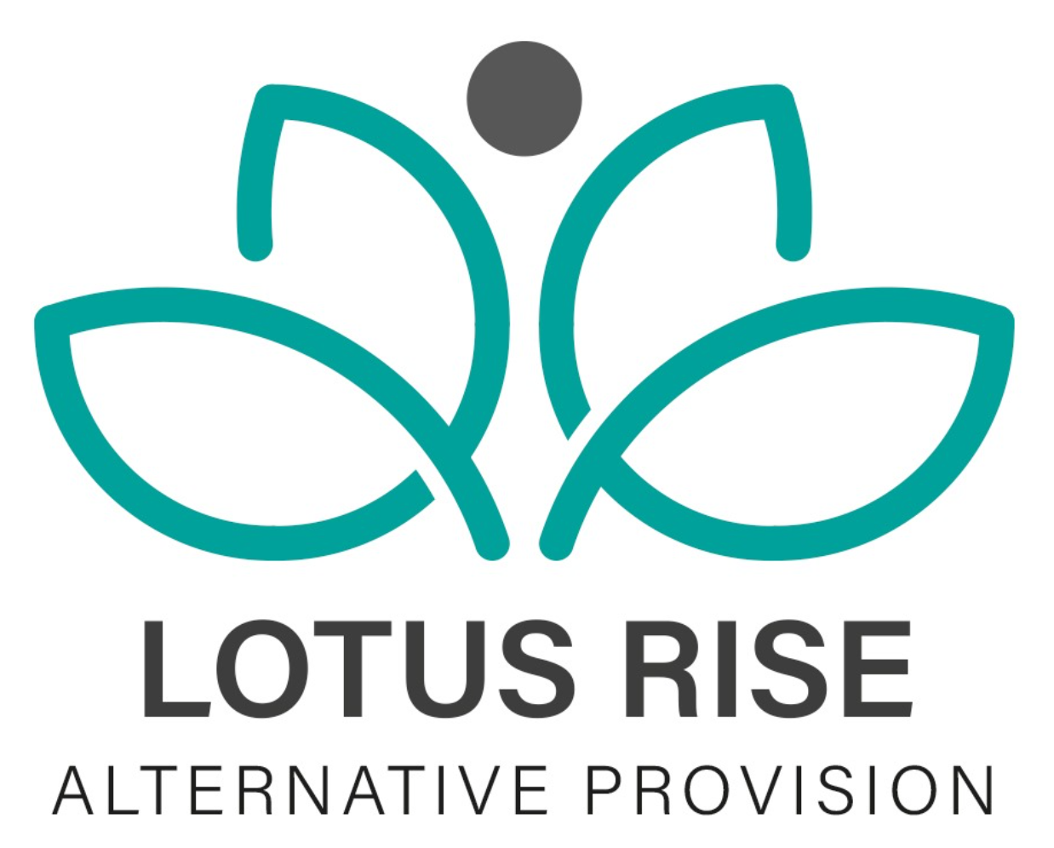

COMPLETED DATE:10/5/24
NEXT REVIEW DATE:10/5/26
Drugs and Substance Misuse Policy

1. Policy Statement
Lotus Rise Alternative Provision is committed to maintaining a safe, supportive, and healthy environment for all students, staff, visitors, and professionals. Drug and substance misuse poses serious risks to health, safety, wellbeing, behaviour, and learning. This policy outlines how Lotus Rise seeks to prevent, identify, and respond to drug and substance misuse in a clear, consistent, and safeguarding-led manner.
Lotus Rise operates a zero-tolerance approach to the possession, use, supply, or distribution of illegal drugs and substances on its premises, during off-site or community-based activities, or at any time when individuals are representing the provision.

2. Scope of the Policy
This policy applies to all students attending Lotus Rise Alternative Provision, all staff, mentors, volunteers, contractors, and any visitors or professionals working on behalf of the provision. It applies during on-site provision, off-site learning, work placements, trips, and any activity linked to Lotus Rise.

3. Definitions
For the purpose of this policy, drugs and substances include illegal drugs, new psychoactive substances (also known as legal highs), alcohol, solvents and volatile substances, and prescription or over-the-counter medication that is misused, shared, or taken without a valid prescription.

4. Aims and Objectives
The aim of this policy is to safeguard the health, safety, and wellbeing of all students and staff, to prevent drug and substance misuse through education and early intervention, and to ensure that any incidents are managed in a fair, proportionate, and consistent way. Lotus Rise seeks to respond to substance misuse through a child-centred and restorative approach while recognising its safeguarding responsibilities and legal duties. Partnership working with parents, carers, schools, and external agencies is central to this approach.

5. Education and Prevention
Lotus Rise places strong emphasis on prevention through education and positive relationships. Students are supported to develop an understanding of the risks and consequences of drug and substance misuse through Life Skills and PSHE learning, targeted interventions, and one-to-one mentoring. Open and honest discussions are encouraged in an age-appropriate way, allowing students to ask questions and develop informed decision-making skills. Where appropriate, students may be signposted to external support services.

6. Medication
Any prescribed medication must be declared by parents or carers and stored securely within the provision. Students are not permitted to carry medication unless this has been agreed as part of a medical care plan. Medication will only be administered in line with written parental consent and medical guidance.

7. Identification and Concerns
All staff have a responsibility to remain vigilant to possible indicators of drug or substance misuse. This may include changes in behaviour, mood, attendance, or engagement, as well as physical indicators such as smell, drowsiness, or agitation. Any concerns must be reported immediately to the Designated Safeguarding Lead or Deputy Designated Safeguarding Lead and recorded in line with Lotus Rise safeguarding procedures.

8. Procedures Where Substance Misuse is Suspected
If a student is suspected of being under the influence of drugs or substances, the priority will always be the student’s safety and wellbeing. The student will be supervised closely and supported in a calm and non-judgemental manner. Medical attention will be sought immediately if there are any concerns about the student’s health. The Designated Safeguarding Lead will be informed without delay, parents or carers and the home school will be contacted, and the incident will be recorded on the appropriate safeguarding system.

9. Possession, Use, or Supply of Substances
Where substances are found on a student or on the premises, they will be confiscated and secured by senior staff. Any illegal substances will be handed to the police in line with legal requirements. The Designated Safeguarding Lead will assess the situation as a safeguarding concern and determine next steps. Parents or carers and the home school will be informed, and appropriate action will be taken. Lotus Rise recognises the distinction between use and supply. Any concerns regarding supply or intent to supply will be treated as a serious safeguarding matter and referred to the appropriate external agencies.

10. Sanctions and Support
Responses to incidents will be proportionate, individualised, and focused on education and safeguarding rather than punishment alone. Depending on the circumstances, this may include additional supervision, adjustments to the student’s timetable, one-to-one mentoring, referral to specialist substance misuse services, or the implementation of behaviour or safety plans. In serious cases, fixed-term or permanent exclusion may be considered.

11. Safeguarding and Confidentiality
Drug and substance misuse is always treated as a safeguarding concern at Lotus Rise. Information will be shared on a need-to-know basis in line with safeguarding legislation and guidance. Confidentiality cannot be maintained where doing so would place a child or others at risk. All records will be stored securely.

12. Staff Responsibilities
All staff are expected to uphold this policy at all times and act as positive role models. Staff must report concerns immediately, follow safeguarding procedures, and must never be under the influence of drugs or alcohol while working. Any breach of this policy by staff will be treated as a serious disciplinary matter.

13. Partnership Working
Lotus Rise works closely with parents and carers, home schools, safeguarding teams, health professionals, substance misuse services, and other relevant agencies to ensure that students receive appropriate support and intervention.

14. Monitoring and Review
This policy will be reviewed annually and updated in line with statutory guidance and local authority advice. It may also be reviewed following any serious incident involving drugs or substance misuse.

15. Linked Policies
This policy should be read in conjunction with the Safeguarding and Child Protection Policy, Behaviour Policy, Health and Safety Policy, Attendance Policy, and Searching, Screening and Confiscation Policy.
Approved by the Senior Leadership Team, Lotus Rise Alternative Provision.
This policy is reviewed annually.

Reviewed- Updated | By who?
1/5/2025 | Edawber

