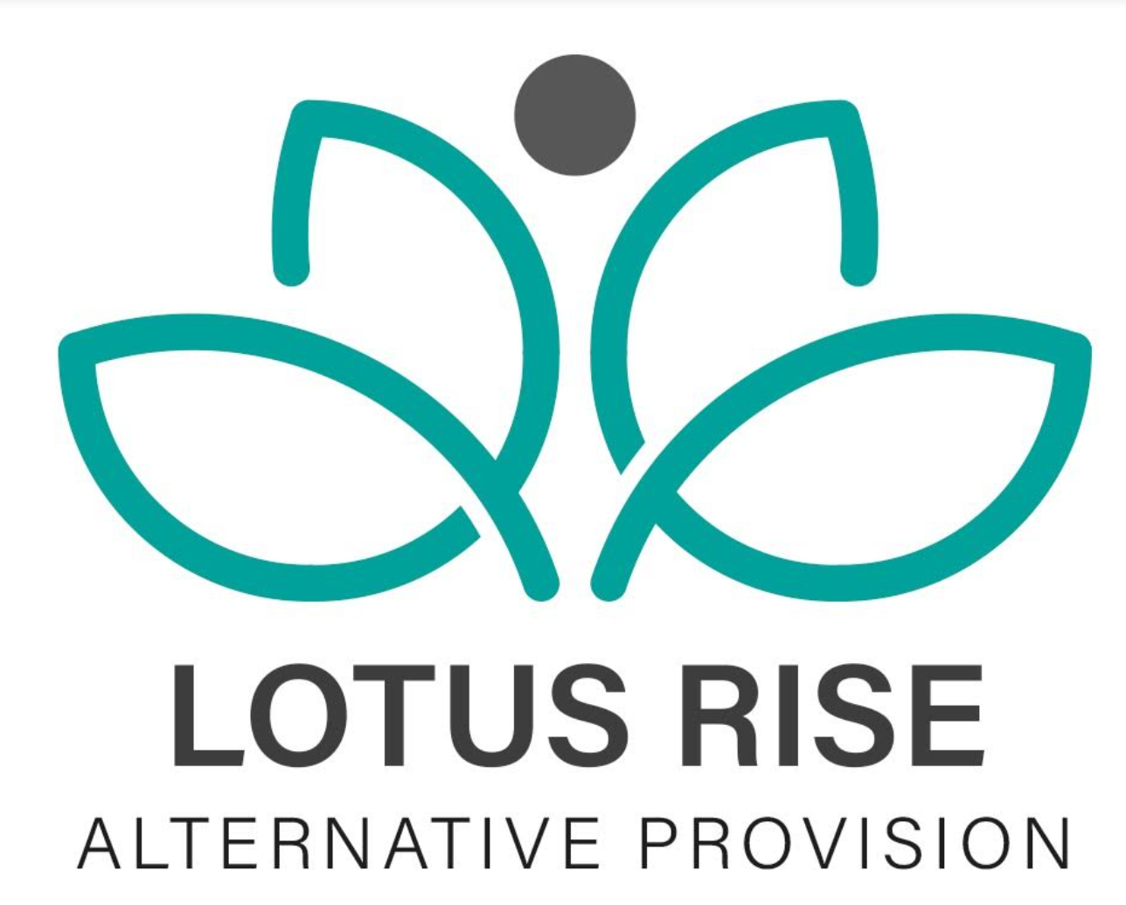
COMPLETED DATE:9/5/24
NEXT REVIEW DATE:9/5/26
HEALTH AND SAFETY POLICY
STATEMENT OF INTENT
Lotus Rise Alternative Provision believes high standards of Health, Safety and Environmental control are an essential part of good business management.
Lotus Rise recognises its health and safety duties under the Health and Safety at Work Act 1974 and the Management of Health and Safety at Work Regulations 1999 and other subsequent enactments or relevant legislation. Senior management at Lotus Rise recognise the legal framework as the mine standard to be achieved. Lotus Rise will meet its responsibilities to provide a safe and healthy working environment for employees, students, visitors and anyone affected by our business activities. Details of how this will be achieved are detailed in this health and safety policy.
Lotus Rise will ensure that effective consultation takes place with all employees on health and safety matters and that individuals are consulted before allocating particular health and safety functions to them.
Where necessary Lotus Rise will seek specialist advice to determine the risks to health and safety in the establishment and the precautions required to deal with them.
Lotus Rise will provide sufficient information and training in health and safety matters to all employees in respect to the risk to their health and safety. Lotus Rise requires the support of all staff to enable the maintenance of high standards of health and safety in all activities.
All employees must comply with the legal obligations placed upon them and cooperate with the company in meeting its legal requirements. Lotus Rise is committed to continually improving its health and safety performance.
Lotus Rise will adopt a proactive approach to health and safety and this will be reflected in the key performance indicators (KPIs) that are adopted.
Signed ...........Ravinder Digwa............... (Managing Director)
ORGANISATION AND RESPONSIBILITIES
Responsibilities of the Managing Director (MD):
Overall responsibility for health and safety rests with the Managing Director, Ravinder Digwa.
The Managing Director has appointed a health and safety professional to
assist with the formulation and implementation of a health and safety management
system to assist in full compliance with legal obligations. The health and safety
management system in place will follow the HSE guidance HSG65 and will adopt the
recommended strategy “plan, do, check, act.”
The health and safety management system will include;
• Full recognition of responsibilities held and a clear commitment to the provision of
a safe and healthy working environment.
• A clear pathway from planning to implantation to measurement of performance to
reviewing performance.
• Regularly reviewing health and safety arrangements at the staff meetings and
implementing new arrangements where necessary.
• Ensuring that the site and premises are maintained in a safe condition.
• Ensuring that risk assessments are completed and recorded of all the work
activities including those off site which could constitute a significant risk to the
health and safety of employees or others.
• Ensuring that the statement of intent and other relevant health and safety
documentation is drawn to the attention of all employees.
• Prioritising action on health and safety matters where resources are required from
the provision’s budget, seeking further advice where necessary and ensuring that
action is taken.
• Lotus Rise to have access to health and safety competent advice as stated in Regulation 7 of the Management of Health and Safety at Work Regulations.
• Employees to have necessary competence to conduct their duties in relation to
health and safety matters as well as operational matters.
• Promoting high standards of health and safety within the provision.
• Active and reactive monitoring of health and safety matters within Lotus Rise including health and safety inspection reports, near miss reporting, accident reporting,
health and safety training records and working environment questionnaires.
• The day to day management of health and safety matters in the provision in
accordance with the health and safety policy and ensuring the health and safety
arrangements are carried out in practice.
• Ensuring that risk assessments are completed and recorded of all Lotus Rise work
activities including those off site which could constitute a significant risk to the
health and safety of employees or others.
• Ensuring that remedial action is taken following health and safety inspections.
• Ensuring that information received on health and safety matters is passed to the
appropriate people.
• Identifying staff health and safety training needs and arranging for them to be
provided.
• Monitoring purchasing and maintenance of equipment and materials and ensuring
that it complies with current health and safety standards.
• Monitoring contractors and ensuring that only competent, approved contractors
are engaged to work on the school site.
• Seeking specialist advice on health and safety matters where appropriate.
• Ensuring that a procedure is in place to deal safely with persons on the premises
who may be under the influence of alcohol or drugs.
• Attending appropriate Health and Safety Training Courses including IOSH
Managing Safely to enable him/her to discharge his/her duties effectively.
• Promoting health and safety matters throughout the provision.
• Maintenance of health and safety documentation associated records to ensure
they remain up to date with current legislation and good practice.
• Ensuring that the Health and Safety Notice Board is kept up to date.
• Ensuring that the correct accident reporting procedures are followed and that
where appropriate accidents, incidents and near misses are investigated.
• Providing health and safety induction training for all new employees.
• Maintenance of health and safety training records including the provision of
refresher training.
• Ensuring that all statutory inspections are completed and records kept.
• Ensuring that emergency drills and procedures are carried out regularly and
monitored for effectiveness.
• Monitoring contractors on site and conducting a formal, documented induction.
• Drawing up and reviewing policies, procedures and risk assessments regularly (at
least once annually).
• Carrying out regular health and safety monitoring inspections and making reports
where appropriate.
• Ensuring follow up and remedial action is taken following health and safety
inspections.
• Passing on health and safety information received to the appropriate people.
• Acting on health and safety reports from above and below in the hierarchy.

To that end the Director of Health and Safety will:
• Keep abreast of changes to and updates to legislation by attending the Institute of
Occupational Safety and Health (IOSH) quarterly meetings and reading associated
literature.
• Pass on relevant information on health and safety matters to the Managing
Director as and when necessary.
• Review this policy in order to maintain relevance to the business.
• Review all risk assessments in response to significant changes or periodically.
• Carry out health and safety inspections.
• Ensuring health and safety is a standing agenda item at monthly staff meetings.
• be a focal point for health and safety for all staff members.
• Ensure staff are adequately trained in health and safety matters.
Responsibilities of staff
All staff employed at Lotus Rise have a responsibility to;
• Take reasonable care for the health and safety of themselves and others when
undertaking their work.
• Checking classrooms/work areas is safe.
• Checking equipment is safe before use.
• Ensuring safe working procedures are followed as outlined within health and
safety policy and risk assessments.
• Co-operating with the Managing Director on all matters relating to health and
safety by complying with the health and safety policy.
• Not intentionally or recklessly interfering with or misusing any equipment or fittings
provided in the interests of health safety and welfare.
• Reporting immediately to their line manager any serious or immediate danger.
• Reporting to their line manager any shortcomings in the arrangements for health
and safety.
• Ensure that they only use equipment or machinery which they are competent to
use or have been trained to use.
• All staff have responsibility to follow the COVID-19 risk assessment and ensure
the safety and hygiene of themselves, other staff and students.
Anyone found working to their own or other persons detriment, in disregard to this
policy or other procedure could be held personally responsible in law and may be
subject to disciplinary proceedings which may lead to their dismissal.
Responsibilities of the Students:
• Due to the nature of the students at Lotus Rise it is unlikely that they will familiarise
themselves with this policy and even less likely to follow any requirements
contained within. It is therefore the responsibility of the staff member in charge to
ensure that students.
• Cooperate with the provision with regard to health and safety and do not interfere
with or misuse anything provided in the interest of health, safety or welfare.
• To maintain personal hygiene and follow Lotus Rise’s COVID-19 procedures and risk
Assessment.
ARRANGEMENTS
The Managing Director and the Director for Health and Safety will meet annually to discuss corporate strategy regarding health and safety and will set a budget for health and safety training.
Health and Safety Communication
Staff meetings are held weekly and health and safety is a standing agenda item. The item is introduced by the Director for health and safety or the Managing Director and all staff are given an open floor to discuss any health and safety issues.
Health and Safety Responsibility
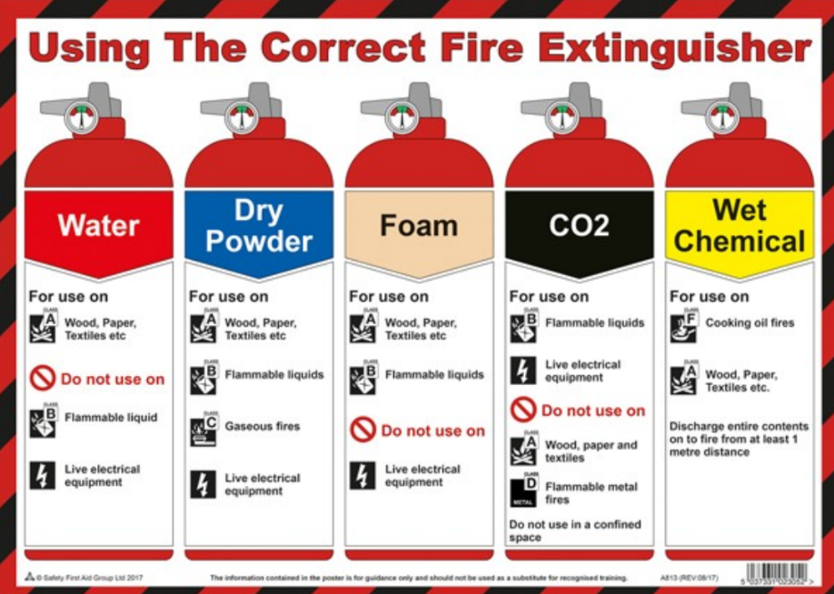
All staff will undergo fire safety training and understand the use of the correct fire extinguishers.
It is all staff members responsibility whilst on outreach in a building to know where all fire exits are and the building fire evacuation procedure.
Accident, Dangerous Occurrence, Violent Incident and Near Miss Reporting
and Investigation
A dangerous occurrence is an unintended event that does not result in a reportable accident but does have the potential to cause harm. There is a specified list of dangerous occurrences issued by the HSE that should be reported. If you are unsure, report it to Ravinder Digwa.
A near miss is something that has not caused harm but has the potential to cause harm. If you are unsure, or on the side of caution and report to Ravinder Digwa. Any employee who has or witnesses an accident, dangerous occurrence, verbal abuse or actual or threatened violence or near miss, or to whom one is reported, should report it to the first aider or Ravinder Digwa who will make an entry in the accident report book as soon as possible after the event.
Accident/incident book is kept by the following people at the location specified:
Location of accident/incident | Office Cupboard Above Sink
Book Person in Charge of Accident Reports | Ravinder Digwa

Accident reports should be completed by competent First Aid staff and the school
and the parent/guardian of the child informed immediately. The Managing Director
should then be informed.
The person responsible for monitoring accidents and incidents to identify trends and
patterns: Managing Director.
Where accidents are found to be caused by faulty plant, equipment, premises or
unsafe systems of work action must be taken to remove or isolate the hazard and
warn people until the necessary modifications or repairs can be made.
The requirements of RIDDOR 2013 will be followed in respect of any reportable
accident, dangerous occurrence or near miss.
First Aid
The terms of the Health and Safety (First Aid) Regulations 1981 will be complied with
as a minimum standard of cover and practice.
The following employees are first aiders have been trained to First Aid at Work level
The following employees are appointed persons have been trained to Emergency
Aid for Schools level:
___________________
___________________
___________________
The names of current first aiders and appointed persons emergency aiders are
displayed on staff badges and in the office.
The Managing Director is responsible for ensuring first aid qualifications are
maintained. This will be done on the annual review of this policy.
The Managing Director is responsible for ensuring first aid is available to staff and
students during working hours.
First aid boxes and first aid record books are kept at the following points in the
School.
Location of First Aid Box | Glass Office- On the desk.
First Aid Record Box | Glass Office

Travelling first aid boxes are taken out for any outside activity along with a mobile
phone to call for emergency services if needed.
A termly check of the first aid box is carried out by the Managing Director and re-stocked as necessary.
Any items used are reported to the Managing Director upon reporting an accident.
The nearest medical centre is: Highcroft Surgery, High Street, Arnold, Nottingham.
Their telephone number is: 0115 8832330.
The closest accident and emergency department is Queens Medical Centre:
0115 9249924.
Administration of Medicines
No member of staff at Lotus Rise is authorised to administer or keep medication under any circumstances.
Risk Assessments
The Managing Director will be responsible for ensuring that a general survey of the
school's work activities including extra-curricular, extra-mural activities, work carried
out by contractors or volunteers on site is carried out. The survey will be undertaken
at the beginning of the September term. This will ensure risk assessment are
produced and appropriately communicated to all staff and students. The Director of
Health and safety is responsible for the implementation and the physical production
of risk assessments.
Risk assessments will form part of the general induction course and subsequent
health and safety training days which are carried out at the end of the September
term.
All employees must report any hazards that could be a cause of serious or imminent
danger, e.g. damaged electrical sockets, broken windows, suspected gas leaks, wet
or slippery floors immediately, either in person or by telephone to the Director of
Health and safety or Managing Director.
Verbal reports can be followed up in writing using the hazard reporting form which
can be found in the health and safety file by the Managing Director.
Defective furniture must be taken out of use immediately and reported to the
Managing Director.
Where necessary Lotus Rise will seek specialist advice to determine the risks to health and safety in the establishment and the precautions required to deal with them.
House Keeping and Disposal of Waste
Rubbish awaiting collection must never be left where it obstructs escape routes or
could aid the production and spread of fire and smoke. It must always be taken out
of the building and in our refuse bin. This is the responsibility of all staff.
All staff are responsible for ensuring the good housekeeping of their own rooms and
the building.
Gedling Borough Council is responsible for the removal of Lotus Rise waste. Any
hazardous or clinical substances should be disposed of correctly by Lotus Rise staff
following guidance from the council.
Repairs and Maintenance
The Managing Director is responsible for ensuring that any damage or wear and tear
of the premises does not constitute a hazard. Defective furniture will be taken out of
use immediately and repaired or replaced. Report any hazards of this type to the
Managing Director.
Premises Security
All staff have permission and are responsible for locking and unlocking the building
on a daily basis, disarming security alarms. Staff are aware of the lone working
policy and this must be adhered to if they own their own.
For any callouts out of working hours are the responsibility of the Managing Director.
Severe Weather
During periods of severe weather, arrangements for maintaining safe access to, from
and within the premises (e.g. clearing snow and ice) will be dealt with by all staff who
are first on site.
Health and Safety Training
A full health and safety induction is given to all staff upon commencing at Lotus Rise.
The Managing Director is responsible for coordinating the provision of the health
and safety training needs of teaching staff and is responsible for reviewing the
effectiveness of the training. Records of training will be kept in the CPD file.
An annual inspection will take place by the Managing Director and findings will be
discussed with all staff during the monthly staff meetings.
Employees who feel that they have a need for health and safety training of any kind
should notify the Managing Director in writing or during the monthly staff meetings.
Manual Handling of Objects and Manual Handling of People
The Managing Director is responsible for identifying hazardous manual handling
activities involving objects and arranging for their elimination or where necessary a
risk assessment to be created.
All staff are aware and have received training in manual handling.
Work Equipment
Any work equipment must be used following the manufacturers guidelines and
training that has been given.
Students must be fully supervised by staff if using equipment and must have been
trained and instructed beforehand. A risk assessment will be put into place as
necessary.
If equipment is faulty or damaged staff must not take it upon themselves to make
repairs. The Managing Director must be told and repairs made by competent
persons or replaced as required.
Catering Equipment
The Managing Director is responsible for selection, inspection, maintenance and
training of catering equipment.
The relevant catering tutor is responsible for the training, supervision and safe use of
equipment when working with students.
The Managing Director is responsible for completing a risk assessment.
The relevant tutor is responsible for ensuring an adequate schedule of deep cleaning
is carried out in the food area and that is logged accordingly.
Health and Fitness Equipment
The Managing Director is responsible for completing a risk assessment on all
activities carried out during the Health and Fitness lessons in conjunction with the
relevant staff.
The tutor is responsible for supervising the class at all times when using fitness
equipment and is also responsible for daily visual inspections on any equipment prior
to use.
Portable Electrical Appliances
The Managing Director is responsible for ensuring portable appliances testing is
carried out at appropriate intervals and is recorded in the health and safety log.
Termly visual inspections are to be carried out by the Managing Director to identify
any faults or concerns. A risk assessment is carried out and updated as required.
Staff must not bring onto the premises any portable electrical appliances unless and
The appliances have been portable appliances tested. The person responsible for
authorising their use on the premises is the Managing Director:
Display Screen Equipment (DSE)
DSE assessments will be carried out and findings will be acted upon by the
Managing Director. Where applicable eye tests will be given to employees following
HSE guidelines.
Personal Protective Equipment (PPE)
Suitable PPE will be provided free of charge, where identified as necessary in a risk
assessment.
All employees are responsible for informing their manager as soon as they become
aware of a need to repair or replace PPE, which they use. The requirements of the
COSHH Regulations 2002 and other legislation will be satisfied. All necessary
precautions will be taken in the use, storage and transportation of any material or
substance. The least hazardous type of any substance will be used or purchased in
order to minimise any associated risk. There will be regular assessments and
monitoring to ensure that this is achieved.
A COSHH risk assessment will be carried out by the Managing Director and Data
Sheets obtained where necessary,
Cleaning of the site
All members of staff are responsible for arranging to clear up spillages, which occur
whilst they are in charge of the area concerned. Other spillages, leaks or wet floors
should be reported to the Director and Managing Director who will arrange for them
to be dealt with.
All members of staff are responsible for ensuring that hazardous substances or
substances that require special procedures for disposal are disposed of safely and in
according to the appropriate risk assessment sheet.
Provision of Information
The Managing Director is responsible for organising and carrying out termly safety
inspections and must ensure follow up action is completed.
Records of employee’s signatures indicating that they have received, read and
understood health and safety information is kept in the health and safety file.
All new employees will receive a full health and safety induction.
All health and safety documentation will be kept in the health and safety file and the
maintenance will be done by the Managing Director.
The health and safety notice board will be maintained on site and updated by the
Managing Director.
The Health and Safety Law Poster is displayed in the main reception for all staff and
students to view.
The person responsible for ensuring that the appropriate risk assessments and
approval for off site visits is the Managing Director.
Visitors
On arrival all visitors should report to reception where they will be
issued with:
• An identification badge
• Relevant health and safety information
Visitors to sign in the visitors book and To follow the COVID-19
procedures for hygiene and safety.
Contractors will be arranged by the Landlord and the Managing Director. All relevant
health and safety documentation referring to external and major work to the building
will be dealt with by the Landlord and the Managing Director. Any internal building
repairs will be arranged by the Managing Director and risk assessments will be
Requested.
Smoking/Vaping
Smoking/vaping is prohibited in the building and on the street outside, No smoking
signs are displayed in the building and all staff are aware of the policy.
Stress
Regular briefings are held with all staff to ensure stress in the workplace is avoided
and effective plans are put into place to avoid stress related illness.
If staff feel that they are suffering from work related stress, they must speak to the
Managing Director immediately and in confidence.
Counselling is offered if staff deem this necessary as part of our stress management
procedure.
Anyone with any concerns can talk to the Managing Director in confidence at any
time.
Lone Working
Lotus Rise has a lone working policy which must be read and adhered to by all staff. This is kept in the policy file in the office. The policy must be followed at all times for the safety of staff.
Bullying/Harassment
Lotus Rise has a bullying and harassment policy which must be read by all staff. This is kept in the policy file in the office. Any bullying or harassment must be reported to the Managing Director immediately.
Insurances
Lotus Rise have full insurance in place to cover Employers Liability, Public Liability and
Professional Indemnity.
COVID-19
A formal COVID-19 risk assessment has been carried out. This will be updated in
line with Government recommendations and/or other changes. As the situation
Regarding COVID-19 is fluid, the risk assessment will be kept under continual review.
See risk assessment for hazards and control measures. The risk assessment has
been completed by the Managing Director will be responsible for reviewing it weekly
and updating it as necessary.

Review Date | Who
9/5/2025 | edawber

