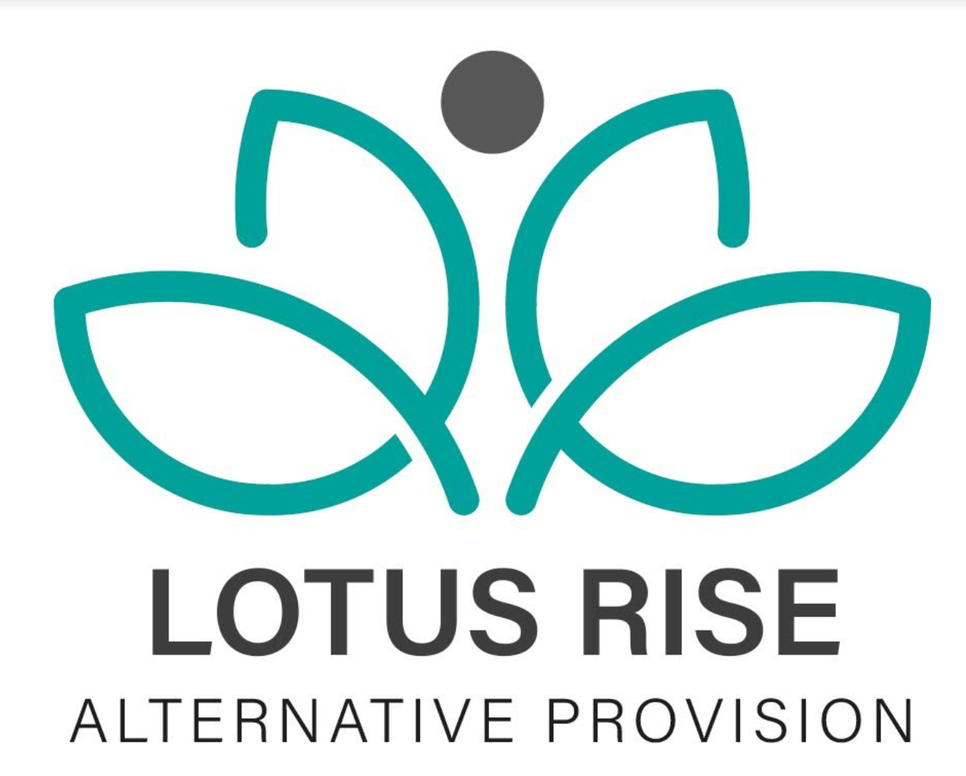

COMPLETED DATE:9/5/24
NEXT REVIEW DATE:9/5/26
SPECIAL EDUCATION NEEDS POLICY (SEN)

Section 1 - Compliance
This policy complies with the requirements laid out in the SEND Code of Practice (2015) and has been written with reference to the following guidance and documents:
- The Equality Act (2010)
- Children and Families Act (2014)
- Special Educational Needs and Disability Regulations (2014)
- Statutory Guidance on Supporting Students at School with Medical Conditions (2015)
- Schools SEND Information Report Regulations (2014)

Section 2 - Vision and Principles
Lotus Rise Alternative Provision is committed to providing an inclusive environment where all children and young people, regardless of their individual needs or abilities, can thrive academically, socially, and emotionally. We aim to eliminate barriers to learning and ensure every student with Special Educational Needs (SEN) has the opportunity to reach their full potential.
We believe that every child can experience success and positive outcomes through a supportive and personalised approach, underpinned by a culture of high expectations, equity, and care.

Section 3 - Responsibility for the Coordination of SEN Provision
- The person responsible for overseeing the provision for children with SEND is Nicola Brown, SENCO.
- The person responsible for coordinating the day-to-day provision of education for pupils with SEND is also Nicola Brown.
- The SENCO reports to senior leaders and directors and works in collaboration with commissioning schools, external agencies, and families.

Section 4 - Aims and Objectives
We aim to provide every student with access to a broad, balanced, and relevant education in accordance with the Special Educational Needs and Disability Code of Practice (2015). We will support students to:
- Achieve their personal best in academic, social, and emotional outcomes.
- Develop into confident individuals who are able to live fulfilling lives and make successful transitions into adulthood, further education, or employment.
We will:
- Promote and maintain high standards of education and care for children and young people with SEN.
- Enable all students to fully participate in the life of Lotus Rise and the wider community.
- Recognise and celebrate the progress and achievements of all learners.
- Identify SEN early and respond with effective and timely interventions.
- Promote a culture of acceptance and respect for all, irrespective of ability.
- Engage parents/carers in the identification, planning, and review of provision.
- Work collaboratively with external professionals and agencies to meet complex needs.

Section 5 - Definition of Special Educational Needs
A child or young person has SEN if they have a learning difficulty or disability which calls for special educational provision to be made. As per Section 20 of the Children and Families Act 2014:
- A child has a learning difficulty if they: a) Have significantly greater difficulty in learning than the majority of others of the same age; or b) Have a disability which prevents or hinders them from making use of educational facilities normally available to others of the same age.

Section 6 - Arrangements for Coordinating SEN Provision
The SENCO maintains an up-to-date SEN register, provision maps, and student profiles. Staff are provided with access to:
- The SEN policy and current SEN register
- Identification guidance and graduated response framework
- Teaching strategies for various types of SEN
- Pupil profiles detailing needs and provision
- Nottinghamshire's SEND Local Offer
All staff are trained to access, understand, and implement this information to ensure consistent and effective support across the provision.

Section 7 - Identification of Pupils with SEND
Lotus Rise adopts a proactive and evidence-informed approach to early identification. We follow the four categories of need outlined in the SEND Code of Practice (2015):
- Communication and Interaction
- Cognition and Learning
- Social, Emotional and Mental Health (SEMH)
- Sensory and/or Physical needs
All staff have a duty to monitor and raise concerns. Once identified, the SENCO will assess, engage parents, and implement support using the Assess, Plan, Do, Review model. High-quality, differentiated teaching is the starting point for all learners.

Section 8 - The Graduated Response
- Teachers provide high-quality, personalised teaching.
- If progress is limited, teachers consult with the SENCO.
- Interventions are discussed and implemented.
- If progress remains limited, the student is added to the SEN register.
- Support may include:
  - In-class support
  - Specific interventions
  - Small-group or 1:1 sessions
- Progress is monitored termly, using the Assess, Plan, Do, Review framework.
Parents are kept informed throughout, and their input is encouraged.

Section 9 - Evaluating the Impact of Provision
- The SENCO tracks student progress using data, observations, and feedback.
- Termly SEN reviews involve pupils, parents, and staff.
- Impact of interventions is measured and recorded.
- Changes are made based on progress.
- Student voice is central to reviewing and planning provision.

Section 10 - Referral for an Education, Health and Care Plan (EHCP)
If a student's needs are severe, complex, and/or long-term, an EHCP assessment may be requested by Lotus Rise, the commissioning school, or parents. This multi-agency process includes:
- Evidence gathering by education, health, and care professionals
- Parent and pupil input
- SENCO coordination
EHCPs are reviewed annually to ensure provision remains relevant.

Section 11 - Exams Access Arrangements (EAA)
Where a need affects exam access, Lotus Rise works with commissioning schools to:
- Identify and evidence the need
- Refer to specialist assessors
- Implement agreed arrangements in line with JCQ regulations
Support provided must reflect the student's normal way of working. Teaching staff contribute evidence and are trained to recognise and support access needs.

Section 12 - Working in Partnership with Parents
We value and encourage meaningful partnerships with parents to ensure: a. Timely and accurate identification of SEN b. Shared understanding of provision and outcomes c. Co-produced targets and intervention plans
Regular communication includes termly review meetings, phone/email updates, and access to the SENCO. Parents are supported to understand SEN procedures and contribute their views.

Section 13 - Admission Arrangements
Admissions comply with national legislation, including the Equality Act (2010). Students with SEN, including those with EHCPs, are welcomed.
- Additional transition visits and personalised plans are available.
- Information from previous settings is gathered and shared with staff to support effective transition.

Section 14 - Training
All staff receive annual training on SEN and further CPD as needed. New staff are given SEN induction. Staff are supported to:
- Implement quality-first teaching
- Understand common SEN needs
- Use individual pupil strategies
The SENCO maintains training records and ensures staff understand their responsibilities.

Section 15 - Links to Support Services / Other Agencies
The SENCO liaises with a wide range of external professionals, including:
- Nottinghamshire Educational Psychology Service
- Behaviour Support Service
- Children’s Social Care
- Speech and Language Therapy (SALT)
- Occupational Therapy
- Specialist Outreach and Inclusion Services
- NSPCC
- CAHMS
These partnerships ensure that students receive coordinated and holistic support.

Section 16 - Complaints Procedure
Lotus Rise is committed to resolving concerns swiftly and constructively. If parents or carers have concerns about SEN provision:
- Speak with the SENCO (Nicola Brown) in the first instance.
- If the issue is unresolved, raise the concern with the Director or Senior Leadership Team.
- Formal complaints should follow the Lotus Rise Complaints Policy, which is available upon request or from our website.
We take all concerns seriously and aim to work in partnership with families to resolve them.

Review Date | By Who?
9/6/2025 | edawber

