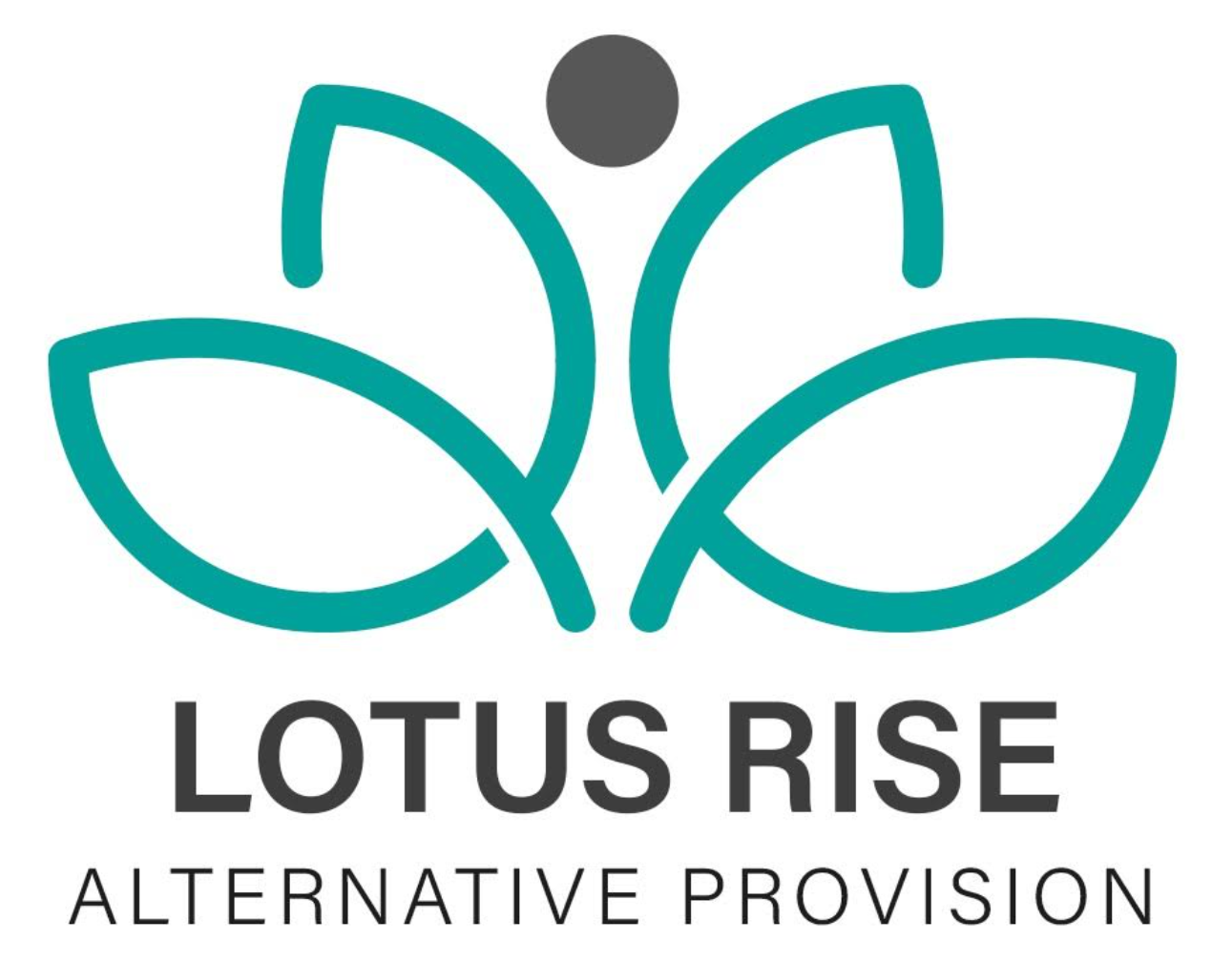
COMPLETED DATE:9/5/24
NEXT REVIEW DATE:9/5/26
Whistle Blowing Policy
1.Introduction
The Directors of Lotus Rise Alternative Provision are committed to the highest possible standards of honesty and integrity, and we expect all staff to maintain these standards. However, all organisations face the risk of things going wrong from time to time, or of unknowingly harbouring illegal or unethical conduct. A culture of openness and accountability is essential in order to prevent such situations occurring or to address them when they do occur. This policy does not form part of any employee's contract of employment and it may be amended at any time.
2. Scope and purpose
The aims of this policy are:
(a) To encourage staff to report suspected wrongdoing as soon as possible, in the knowledge that their concerns will be taken seriously and investigated as appropriate, and that their confidentiality will be respected.
(b) To provide staff with guidance on how to raise concerns.
(c) To reassure staff that they should be able to raise genuine concerns without fear of reprisals, even if they turn out to be mistaken.
2.2 This policy applies to all employees of Lotus Rise, contractors, casual / agency staff and volunteers (collectively referred to as staff in this policy).
3. What is whistleblowing? Whistleblowing is the disclosure of information which relates to suspected wrongdoing or dangers at work. The law provides protection for workers who raise legitimate concerns about specified matters or "qualifying disclosures". A qualifying disclosure is one made in the public interest by a worker who has a reasonable belief that wrongdoing or dangers at work.
This may include:
(a) criminal activity.
(b) miscarriages of justice.
(c) danger to health and safety.
(d) damage to the environment.
(e) failure to comply with any legal or professional obligation or regulatory requirements.
(f) bribery.
(g) financial fraud or mismanagement.
(h) negligence.
(i) breach of our internal policies and procedures [including our Code of Conduct].
(j) conduct likely to damage our reputation.
(k) unauthorised disclosure of confidential information.
(l) unethical behaviour
(m) the deliberate concealment of any of the above matters.
A whistle-blower is a person who raises a genuine concern relating to any of the above. If you have any genuine concerns related to suspected wrongdoing or danger affecting any of our activities (a whistleblowing concern) you should report it under this policy.
This policy should not be used for complaints relating to your own personal circumstances, such as the way you have been treated at work. In those cases, you should use the Grievance Procedure. If you are uncertain whether something is within the scope of this policy, you should seek advice from a member of the leadership team.
If your concern is in relation to safeguarding and the welfare of pupils at the Hub you should consider whether the matter is better raised under Lotus Rise’s child protection policy and in accordance with the arrangements for reporting such concerns, i.e. via the designated safeguarding lead, although the principles set out in this policy may still apply.
4. Raising a whistleblowing concern
Most concerns should be raised with the Headteacher. You may tell them in person or put the matter in writing if you prefer. They may be able to agree on a way of resolving your concern quickly and effectively.
If the concern is about the Headteacher this should be raised with the Directors.
If the concern is about one of the Directors it should be referred directly to LADO.
Whether raising concerns in writing or verbally, you should detail the background / history to your concerns, the reason for your concerns and the fact that you are raising your concerns as a whistleblowing matter.
We will arrange a meeting with you as soon as possible to discuss your concern. You may bring a colleague or trade union representative to any meetings under this policy. They must respect the confidentiality of your disclosure and any subsequent investigation.
We will take down a written summary of your concern and provide you with a copy after the meeting. We will also aim to give you an indication of how we propose to deal with the matter.
5. Confidentiality
We hope that staff will feel able to voice whistleblowing concerns openly under this policy. However, if you want to raise your concern confidentially, we will make every effort to keep your identity secret. If it is necessary for anyone investigating your concern to know your identity, we will discuss this with you.
We do not encourage staff to make disclosures anonymously. Proper investigation may be more difficult or impossible if we cannot obtain further information from you. It is also more difficult to establish whether any allegations are credible. Whistle-blowers who are concerned about possible reprisals if their identity is revealed should discuss this with senior leadership and appropriate measures can then be taken to preserve confidentiality. If you are in any doubt you can seek advice from Public Concern at Work, the independent whistleblowing charity, who offers a confidential helpline. Their contact details are given at the end of this policy.
Where we receive anonymous complaints, we will decide about whether to investigate based on:
(a) the seriousness of the issue raised
(b) the credibility of the concern; and
(c) the likelihood of confirming the allegation from other sources
As part of the application of this policy, we may collect, process and store personal data in accordance with our data protection policy. We will comply with the requirements of Data Protection Legislation (being (i) unless and until the GDPR is no longer directly applicable in the UK, the General Data Protection Regulation ((EU) 2016/679) and any national implementing laws, regulations and secondary legislation, as amended or updated from time to time, in the UK and then (ii) any successor legislation to the GDPR or the Data Protection Act 2018) in the collecting, holding and sharing of information in relation to our workforce. Records will be kept in accordance with our Workforce Privacy Notice, our Retention and Destruction Policy and in line with the requirements of Data Protection Legislation.
6. External disclosures
The aim of this policy is to provide an internal mechanism for reporting, investigating and remedying any wrongdoing in the workplace. In most cases you should not find it necessary to alert anyone externally.
The law recognises that in some circumstances it may be appropriate for you to report your concerns to an external body such as a regulator. It will very rarely, if ever, be appropriate to alert the media. We strongly encourage you to seek advice before reporting a concern to anyone external. Public Concern at Work holds a list of prescribed regulators for reporting certain types of concern. Their contact details are at the end of this policy. Alternatively, the list is available from the Department for Business, Energy & Industrial Strategy.
Whistleblowing concerns usually relate to the conduct of our staff, but they may sometimes relate to the actions of a third party, such as a contractor, supplier or service provider. The law allows you to raise a concern with a third party, where you reasonably believe it relates mainly to their actions or something that is legally their responsibility. However, we encourage you to report such concerns internally first. You should contact your line manager or one of the other individuals mentioned earlier.
7. Investigation and outcome
Once you have raised a concern, we will carry out an initial assessment to determine the scope of any investigation. We will inform you of the outcome of our assessment. You may be required to attend additional meetings in order to provide further information.
In some cases, we may appoint an investigator or team of investigators including staff with relevant experience of investigations or specialist knowledge of the subject matter. The investigator(s) will collate findings on the matter and may make recommendations for change to enable us to minimise the risk of future wrongdoing. This will be sent to the Headteacher and / or the Directors for action.
We will aim to keep you informed of the progress of the investigation, its likely timescale and outcome. However, sometimes the need for confidentiality may prevent us giving you specific details of the investigation or any disciplinary action taken as a result. You should treat any information about the investigation as confidential.
If we conclude that a whistle-blower has made false allegations maliciously, or with a view to personal gain, the whistle-blower may be subject to disciplinary action.
8. If you are not satisfied
While we cannot always guarantee the outcome you are seeking, we will try to deal with your concern fairly and in an appropriate way. By using this policy, you can help us to achieve this. If you are not happy with the way in which your concern has been handled, you can raise it with one of the other key contacts mentioned earlier.
9. Protection and support for whistle-blowers
It is understandable that whistle-blowers are sometimes worried about possible repercussions. We aim to encourage openness and will support staff who raise genuine concerns under this policy, even if they turn out to be mistaken. Staff must not suffer any detrimental treatment as a result of raising a genuine concern. Detrimental treatment includes dismissal, disciplinary action, threats or other unfavourable treatment connected with raising a concern. If you believe that you have suffered any such treatment, you should inform one of the contact people mentioned earlier immediately. If the matter is not remedied, you should raise it formally using our Grievance Procedure. Staff must not threaten or retaliate against whistle-blowers in any way. Anyone involved in such conduct will be subject to disciplinary action.
Confidential support and counselling are available if required.
10. Review of policy
This policy is reviewed every year. We will monitor the application and outcomes of this policy to ensure it is working effectively.
11. Contacts
• Whistleblowing Officer –
• Headteacher: -
• External auditors
• Confidential counselling advice / support via
• LADO
• Public Concern at Work (Independent whistleblowing charity) Helpline: (020) 7404 6609
• E-mail: whistle@pcaw.co.uk Website: www.pcaw.co.uk
• The NSPCC whistleblowing helpline: 0800 028 0285 E-mail: help@nspcc.org.uk
• List of regulators https://www.gov.uk/government/publications /blowing-the-whistlelist-of-prescribed people-and-bodies--2/whistleblowing-list-of prescribed-people-andbodies
• Trade Unions If you are a member of a Trade Union, you may choose to contact them for advice and support.

Review Date | By Who?
9/6/2025 | edawber

