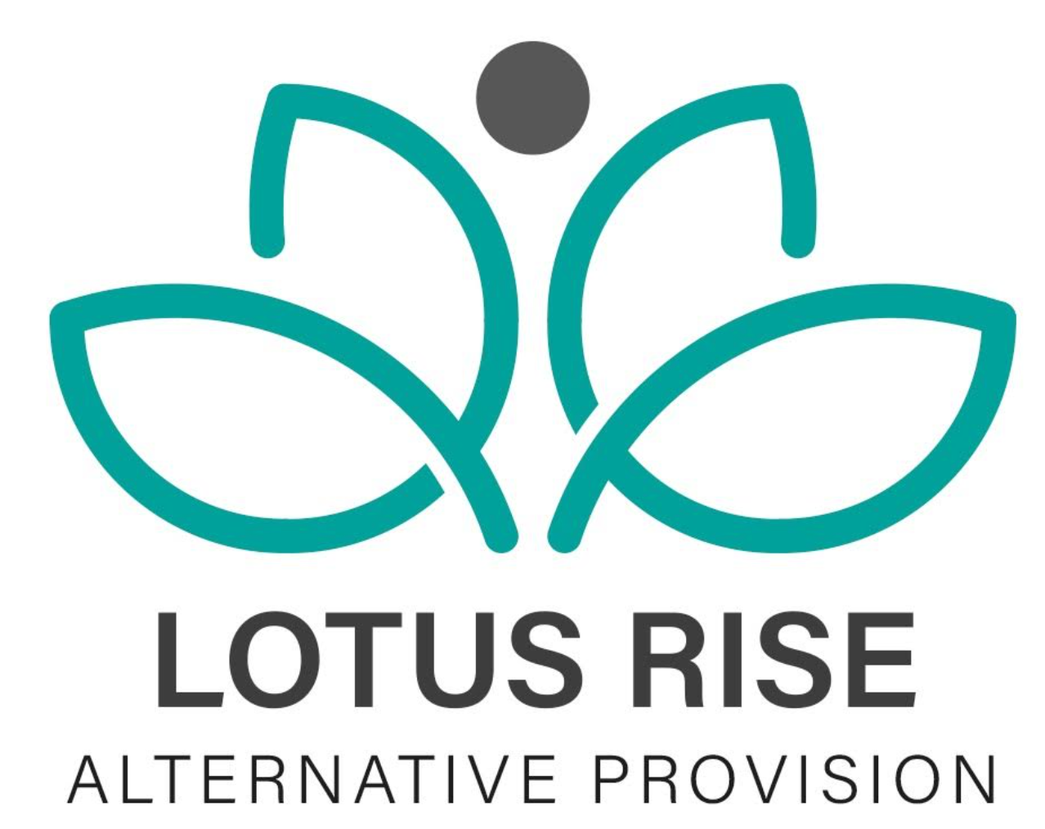
COMPLETED DATE:9/5/24
NEXT REVIEW DATE:9/5/26

E-SAFETY / ONLINE SAFETY POLICY

Contents
- Introduction and Overview
• Rationale and Scope
• Roles and responsibilities
• Communication
• Handling complaints
• Review and Monitoring
- Education and Curriculum
• Student E-Safety / Online Safety Curriculum
• Staff training
- Expected Conduct and Incident Management
- Managing the ICT Infrastructure
• Internet access, security (virus protection) and filtering
• Network management
• Passwords policy
• Email
• School website
• Social networking
• Video conferencing
- Data Security
• MIS access
• Data transfer
- Equipment and Digital Content
• Personal mobile phones and devices
• Digital images and video

1. Introduction and Overview

Rationale
The purpose of this policy is to:
- set out the key principles expected of all members of the community at Lotus Rise Alternative Provision with respect to the use of ICT-based technologies
- safeguard and protect the children and staff of Lotus Rise Alternative Provision
- assist staff working with children to work safely and responsibly with the internet and other communication technologies and to monitor their own standards and practice
- set clear expectations of behaviour and codes of practice relevant to responsible use of the internet for educational, personal or recreational use
- have clear structures to deal with online abuse such as cyberbullying which are cross-referenced with other policies
- ensure that all members of the Lotus Rise community are aware that unlawful or unsafe behaviour is unacceptable and that disciplinary or legal action may be taken where appropriate
- minimise the risk of misplaced or malicious allegations made against adults who work with students

The main areas of risk for our community include:

Content
- exposure to inappropriate content, including pornography, violence, substance misuse
- lifestyle sites promoting self-harm, eating disorders or suicide
- hate-based content
- misinformation and unreliable content

Contact
- grooming
- radicalisation and extremism
- cyberbullying
- identity theft and hacking

Conduct
- sharing personal information
- digital footprint and online reputation
- excessive screen time and online gaming risks
- sexting / sharing of indecent images (SGII)
- copyright infringement

Scope
This policy applies to all members of Lotus Rise Alternative Provision, including:
- staff
- students
- volunteers
- parents/carers
- visitors and community users
This includes use of all ICT systems, devices and online platforms both in and out of the provision where linked to Lotus Rise activity.

Roles and Responsibilities

Managing Director / Directors
- overall responsibility for online safety and safeguarding systems
- ensure compliant filtering and monitoring systems are in place
- ensure compliance with Keeping Children Safe in Education (KCSIE 2025)
- ensure staff training is up to date
- ensure safeguarding and online safety incidents are recorded and acted upon
- liaise with IT providers and DSL

All Staff
- take responsibility for safe use of ICT
- follow safeguarding and online safety policies
- report concerns immediately
- use professional communication only
- never use personal devices to contact students or families
Staff must be aware that online behaviour, including outside of work, may be subject to safeguarding review where it impacts professional duties.

Parents / Carers
- support the school’s online safety approach
- understand acceptable use expectations
- report concerns relating to online behaviour

Communication
Policy is shared via:
- website publication
- staff induction pack
- safeguarding training
- student induction

Handling Complaints
Lotus Rise recognises that:
It is not possible to guarantee that inappropriate content will never be accessed due to the nature of the internet.
Sanctions may include:
- counselling or intervention
- parental involvement
- restriction of ICT access
- referral to police or safeguarding partners

Filtering and Monitoring (UPDATED SECTION)
Lotus Rise complies with:
Keeping Children Safe in Education (KCSIE 2025)
UK Safer Internet Centre guidance
Responsibilities:
- DSL and IT provider jointly oversee monitoring
- filtering systems are reviewed at least annually
- staff receive training on recognising online risks
- alerts and logs are reviewed routinely

2. Education and Curriculum
Students are taught to:
- stop and think before they click
- verify online information
- recognise bias and misinformation
- understand digital footprints
- stay safe on social media
- report concerns immediately
- understand risks of grooming and exploitation
- understand cyberbullying impact
Education includes awareness of artificial intelligence misuse, deepfakes, and misinformation where age appropriate.

Staff Training
- safeguarding and online safety training provided regularly
- updates provided in staff meetings
- induction includes KCSIE and filtering/monitoring responsibilities

3. Expected Conduct and Incident Management
All users must:
- behave responsibly online
- never access inappropriate content
- report concerns immediately
- respect copyright laws
- maintain professional conduct

Incident Management
- all incidents logged and reviewed
- safeguarding concerns escalated immediately
- parents informed where appropriate
- police contacted where illegal activity is suspected

4. ICT Infrastructure Management

Internet Access and Filtering
- filtered and monitored internet access
- blocked inappropriate content categories
- access reviewed regularly
Filtering systems are reviewed in line with UK Safer Internet Centre and DfE guidance (2025 expectations).

Network Management
- individual logins for all users
- monitored access and audit trails
- secure storage of data in line with UK GDPR
- regular password changes required

Passwords
- strong passwords required
- passwords must not be shared
- changed twice yearly

Email
- professional email accounts only
- no personal email use for school communication
- phishing and spam awareness training provided

School Website
- managed by authorised staff only
- no personal data published
- no student full names with images
- GDPR compliant publishing practices

Social Networking
- staff must not engage with students on personal accounts
- professional boundaries must be maintained
- privacy settings must be secure

Video Conferencing
- only approved platforms used
- sessions supervised appropriately

5. Data Security
- compliant with UK GDPR and Data Protection Act 2018
- MIS access controlled and audited
- data stored securely and encrypted where required
- data breaches reported immediately

6. Equipment and Digital Content

Mobile Phones
Students:
- phones not permitted in lessons unless authorised
- devices may be confiscated if misused
Staff:
- must not use personal devices to contact students
- work devices only for communication
All device use must comply with safeguarding expectations and professional standards.

Digital Images and Video
- parental consent required
- no full names used with images
- images stored securely
- GDPR compliant use of media
Staff must ensure images are appropriate, necessary, and used only for educational or safeguarding purposes.

Review Date | By Who?
9/6/2025 | edawber
20.5.2026 | edawber

