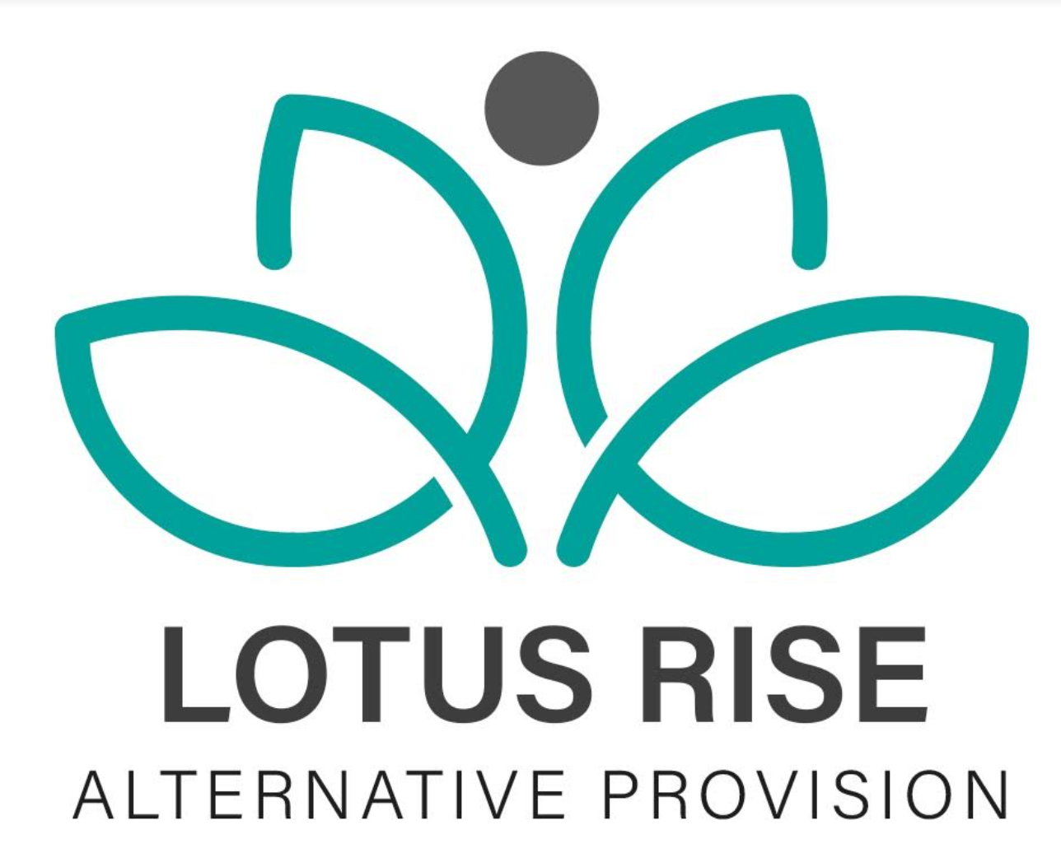
COMPLETED DATE:9/5/24
NEXT REVIEW DATE:9/5/26

HEALTH AND SAFETY POLICY

STATEMENT OF INTENT
Lotus Rise Alternative Provision believes high standards of Health, Safety and Environmental control are an essential part of good business management.
Lotus Rise recognises its health and safety duties under the Health and Safety at Work Act 1974, the Management of Health and Safety at Work Regulations 1999, Reporting of Injuries, Diseases and Dangerous Occurrences Regulations (RIDDOR) 2013, Equality Act 2010, Regulatory Reform (Fire Safety) Order 2005, Control of Substances Hazardous to Health Regulations 2002 (COSHH), and all other relevant legislation and approved guidance. Senior management at Lotus Rise recognise the legal framework as the minimum standard to be achieved.
This policy applies to all Lotus Rise Alternative Provision sites, including:
- Basford Site – Radford Road
- Sherwood Site – Perry Road
This policy also applies to all off-site educational, mentoring, outreach and community-based activities undertaken by staff and learners.
Lotus Rise will meet its responsibilities to provide a safe and healthy working environment for employees, students, visitors and anyone affected by our business activities. Details of how this will be achieved are detailed in this Health and Safety Policy.
Lotus Rise will ensure that effective consultation takes place with all employees on health and safety matters and that individuals are consulted before allocating particular health and safety functions to them.
Where necessary Lotus Rise will seek specialist advice to determine the risks to health and safety in the establishment and the precautions required to deal with them.
Lotus Rise will provide sufficient information and training in health and safety matters to all employees in respect to the risks to their health and safety. Lotus Rise requires the support of all staff to enable the maintenance of high standards of health and safety in all activities.
All employees must comply with the legal obligations placed upon them and cooperate with the provision in meeting its legal requirements. Lotus Rise is committed to continually improving its health and safety performance.
Lotus Rise receives external HR and employment law support from BrightHR.
Lotus Rise will adopt a proactive approach to health and safety and this will be reflected in the key performance indicators (KPIs) that are adopted.
Signed ...........Ravinder Digwa............... (Managing Director)

ORGANISATION AND RESPONSIBILITIES

Responsibilities of the Managing Director (MD)
Overall responsibility for health and safety rests with the Managing Director, Ravinder Digwa.
The Managing Director has appointed a health and safety professional to assist with the formulation and implementation of a health and safety management system to assist in full compliance with legal obligations. The health and safety management system in place will follow the HSE guidance HSG65 and will adopt the recommended strategy “Plan, Do, Check, Act.”
The Managing Director will ensure suitable arrangements are in place across both Lotus Rise sites located at Radford Road (Basford) and Perry Road (Sherwood), including site-specific risk assessments, fire safety arrangements, first aid provision and emergency procedures.
The health and safety management system will include:
- Full recognition of responsibilities held and a clear commitment to the provision of a safe and healthy working environment.
- A clear pathway from planning to implementation to measurement of performance to reviewing performance.
- Regularly reviewing health and safety arrangements at staff meetings and implementing new arrangements where necessary.
- Ensuring that the sites and premises are maintained in a safe condition.
- Ensuring that risk assessments are completed and recorded for all work activities including off-site activities which could constitute a significant risk to the health and safety of employees or others.
- Ensuring that the statement of intent and other relevant health and safety documentation is drawn to the attention of all employees.
- Prioritising action on health and safety matters where resources are required from the provision’s budget, seeking further advice where necessary and ensuring that action is taken.
- Ensuring Lotus Rise has access to competent health and safety advice in accordance with Regulation 7 of the Management of Health and Safety at Work Regulations.
- Ensuring employees have the necessary competence to conduct their duties safely.
- Promoting high standards of health and safety throughout Lotus Rise.
- Active and reactive monitoring of health and safety matters including inspection reports, near miss reporting, accident reporting, training records and working environment questionnaires.
- Ensuring remedial action is taken following health and safety inspections.
- Identifying staff health and safety training needs and arranging for training to be provided.
- Monitoring purchasing and maintenance of equipment and materials to ensure compliance with current health and safety standards.
- Monitoring contractors and ensuring only competent contractors are engaged to work on Lotus Rise premises.
- Seeking specialist advice on health and safety matters where appropriate.
- Ensuring procedures are in place to safely manage persons under the influence of alcohol or drugs.
- Ensuring appropriate health and safety training is completed and refreshed where required, including IOSH Managing Safely or equivalent recognised training.
- Maintaining health and safety documentation and records to ensure they remain up to date with legislation and good practice.
- Ensuring health and safety notice boards are kept up to date at both sites.
- Ensuring correct accident reporting procedures are followed and investigations are completed where appropriate.
- Providing health and safety induction training for all new employees.
- Maintaining health and safety training records including refresher training.
- Ensuring statutory inspections are completed and recorded.
- Ensuring emergency drills and procedures are carried out regularly and monitored for effectiveness.
- Monitoring contractors on site and conducting documented inductions.
- Reviewing policies, procedures and risk assessments annually or sooner where necessary.
- Carrying out regular health and safety inspections and ensuring follow-up actions are completed.

RESPONSIBILITIES OF STAFF
All staff employed at Lotus Rise have a responsibility to:
- Take reasonable care for the health and safety of themselves and others.
- Check classrooms, offices and work areas are safe.
- Check equipment is safe before use.
- Ensure safe working procedures are followed in accordance with policies and risk assessments.
- Cooperate with the Managing Director on all matters relating to health and safety.
- Not intentionally or recklessly interfere with or misuse equipment provided for health and safety purposes.
- Report immediately any serious or immediate danger.
- Report any shortcomings in health and safety arrangements.
- Only use equipment or machinery they are competent or trained to use.
- Follow infection prevention and control procedures and maintain appropriate hygiene standards.
Anyone found working to their own or another person’s detriment in disregard of this policy may be subject to disciplinary action.

RESPONSIBILITIES OF STUDENTS
It is the responsibility of staff members supervising students to ensure that students:
- Cooperate with Lotus Rise regarding health and safety.
- Do not interfere with or misuse anything provided in the interests of health, safety or welfare.
- Maintain appropriate standards of personal hygiene.
- Follow staff instructions relating to health, safety and welfare.

FIRST AID
The terms of the Health and Safety (First Aid) Regulations 1981 will be complied with as a minimum standard of cover and practice.
First aid boxes, accident books and health and safety documentation are stored securely within the main office areas at both Lotus Rise sites.

Location of First Aid Boxes
- Basford Site (Radford Road) – Main Office
- Sherwood Site (Perry Road) – Main Office

Accident and First Aid Records
Accident and first aid records are securely maintained within the office areas at both sites in accordance with GDPR requirements.
Travelling first aid boxes are taken on all off-site activities alongside a mobile phone for emergency contact purposes.
The Managing Director is responsible for ensuring:
- First aid qualifications remain in date.
- First aid provision is available during operational hours.
- First aid boxes are checked termly and restocked where necessary.
Each site will maintain details of the nearest medical centre, urgent care provider and accident and emergency department within the site emergency information file.

ADMINISTRATION OF MEDICINES
Medication will only be administered where appropriate consent forms, risk assessments and storage procedures are in place in accordance with Lotus Rise’s Supporting Students with Medical Conditions procedures.

RISK ASSESSMENTS
The Managing Director is responsible for ensuring that suitable and sufficient risk assessments are completed for all activities undertaken by Lotus Rise.
Risk assessments will include:
- Educational activities
- Outreach work
- Lone working
- Off-site visits
- Transport arrangements
- Mentoring sessions
- Work placements
- Activities undertaken at both permanent Lotus Rise sites
Risk assessments will be reviewed annually or sooner where:
- Significant changes occur
- Following accidents/incidents
- There is reason to suspect they are no longer valid
- Legislation or guidance changes
All staff must report hazards immediately to the Managing Director.

PREMISES SECURITY
Authorised staff members are responsible for securing and accessing Lotus Rise sites in accordance with lone working and safeguarding procedures.
All staff must adhere to the Lone Working Policy.

HEALTH AND SAFETY TRAINING
A full health and safety induction is provided to all staff upon commencing employment at Lotus Rise.
Formal health and safety inspections will be undertaken regularly across both sites, with findings recorded and monitored.
Training records will be maintained within the CPD file.

PORTABLE ELECTRICAL APPLIANCES
Portable Appliance Testing (PAT) will be carried out at appropriate intervals and recorded within health and safety records.
All electrical systems and fixed wiring inspections will also be completed in accordance with statutory requirements.
Staff must not bring electrical equipment onto Lotus Rise premises unless authorised and PAT tested where required.

DISPLAY SCREEN EQUIPMENT (DSE)
Display Screen Equipment (DSE) assessments will be completed for relevant staff in accordance with the Health and Safety (Display Screen Equipment) Regulations 1992.

VISITORS
On arrival all visitors must:
- Report to reception
- Sign in
- Wear identification where provided
- Follow safeguarding and health and safety procedures at all times
Contractors must provide appropriate risk assessments and health and safety documentation before commencing work where applicable.

SMOKING/VAPING
Smoking and vaping are prohibited within Lotus Rise premises, entrances, surrounding access points and during educational activities.

STRESS
Lotus Rise recognises its duty under the Health and Safety at Work Act 1974 to assess and reduce workplace stress risks where reasonably practicable.
Any employee experiencing work-related stress should speak confidentially with the Managing Director.
Appropriate support and wellbeing measures will be considered where required.

INSURANCES
Lotus Rise maintains appropriate:
- Employers’ Liability Insurance
- Public Liability Insurance
- Professional Indemnity Insurance
- Any other legally required insurance coverage

INFECTION PREVENTION AND CONTROL
Lotus Rise will follow current UK Health Security Agency (UKHSA), Department for Education and Public Health guidance in relation to infectious illnesses and infection prevention control measures.

POLICY REVIEW
This policy will be reviewed annually or sooner following:
- Significant incidents
- Legislative changes
- Operational changes
- Updated guidance from the Health and Safety Executive (HSE) or Department for Education
The Managing Director retains overall responsibility for ensuring this policy remains compliant and effectively implemented across all Lotus Rise sites

Review Date | Who
9/5/2025 | edawber
20.5.2026 | edawber

