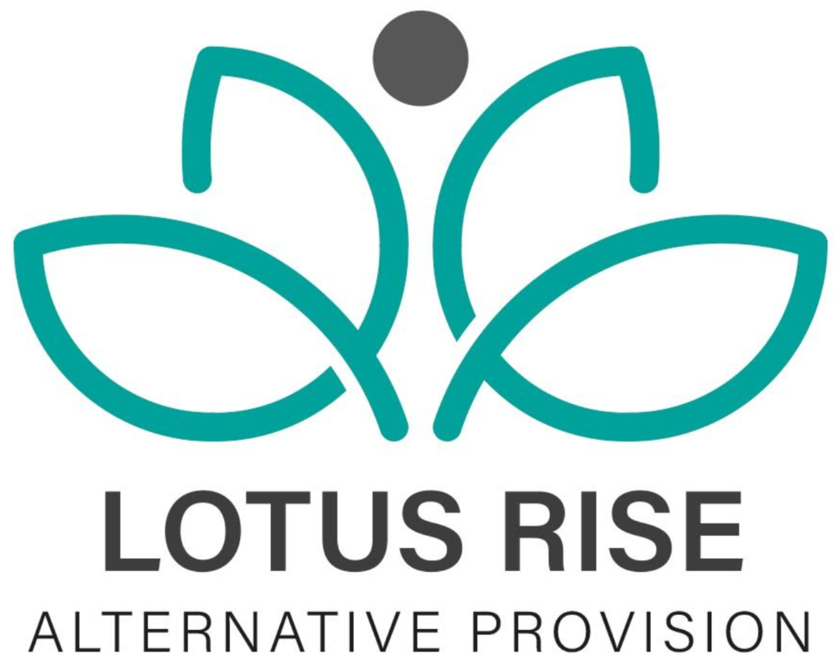

Relationships and Sex Education (RSE) Policy

Purpose
This policy outlines the framework for delivering Relationships and Sex Education (RSE) at Lotus Rise Alternative Provision, ensuring it is age-appropriate, inclusive, and reflective of our commitment to safeguarding and student well-being.

Scope
This policy applies to all staff, students, parents/carers, and external professionals involved in the education and welfare of students at Lotus Rise. RSE is an integral part of the curriculum, tailored to meet the needs of students in a one-to-one alternative provision setting.

Aims of RSE
The aims of RSE at Lotus Rise are to:
- Equip students with the knowledge and skills to develop healthy, respectful relationships.
- Promote understanding of physical, emotional, and mental well-being.
- Ensure students understand consent, boundaries, and how to seek help when needed.
- Foster awareness of diverse family structures, relationships, and sexual orientations in a non-judgmental and inclusive manner.
- Safeguard students by educating them on issues such as online safety, exploitation, and peer pressure.

Curriculum Content
RSE at Lotus Rise follows statutory guidance and is adapted to meet the individual needs of students. Key topics include:
- Relationships:
  - Healthy relationships, consent, and boundaries.
  - Respect, trust, and communication.
  - Recognising and addressing unhealthy or abusive relationships.
- Sex Education:
  - Basic understanding of human reproduction and contraception.
  - Risks of sexually transmitted infections (STIs) and how to prevent them.
  - Safe practices and accessing sexual health services.
- Personal Development:
  - Building self-esteem and resilience.
  - Managing emotions and recognising unhealthy influences.
  - Exploring identity and diversity, including LGBTQ+ inclusivity.
- Online Safety:
  - Risks of sharing personal information and images online.
  - Recognising grooming and exploitation.
  - How to report concerns and seek support.

Delivery of RSE
- RSE will be delivered sensitively by trained staff in one-to-one or small group sessions, ensuring content is appropriate for the student's age, maturity, and understanding.
- Materials and discussions will be inclusive and respect cultural, religious, and personal beliefs.
- Opportunities for open dialogue will allow students to ask questions in a safe and supportive environment.

Parental and Carer Involvement
- Parents and carers will be informed about the RSE curriculum and have the right to request to withdraw their child from certain aspects of sex education (excluding statutory relationships education).
- Staff will work with parents/carers to address any concerns and ensure that students receive consistent messaging at home and within Lotus Rise.

Safeguarding and Confidentiality
- Safeguarding is central to RSE delivery. Any disclosures or concerns raised during RSE sessions will be managed in line with the organisation’s safeguarding policies.
- While confidentiality is respected, students will be informed that safeguarding concerns may need to be shared with the appropriate authorities.

Roles and Responsibilities
- Staff:
  - Deliver RSE in a professional, inclusive, and non-judgmental manner.
  - Attend regular training to ensure best practices are followed.
- Students:
  - Engage with RSE content respectfully and responsibly.
  - Share any concerns or questions with staff as needed.
- Parents/Carers:
  - Support the aims of RSE and communicate openly with staff about their child’s needs.

Reviewed- Updated | By who?
1/5/2025 | Edawber
15/6/2026 | E.dawber

